Contents

APTTIUDE AND Collections Programs 3

Number of occurrences of 2 as a digit in numbers from 0 to n 3

Program to count the total number of words in a string 5

Find closest number in array 6

LINQ,EF AND c# FUNCTIONS & collections 8

What is anonymous type in C#? 8

Expression Lambdas 9

Why anonymous types are better than tuples ? 9

What are the three types of Generic delegates in C#? 10

Action is a delegate, 11

Func 11

Predicate 11

What is IEnumerable in C#? 12

Key Points 12

C# yield Example 12

Q& A 13

Take()**method** 14

What is the difference between First() and Take(1)? 14

Mention what is the role of DataContext classes in LINQ? 14

What are the types of LINQ? 15

What are Anonymous Types? 15

C# - Anonymous Method 16

Anonymous Method Limitations 16

Could you explian what is the exact deference between deferred execution and Lazy evaluation in C#? 17

Define what is Let clause? 17

Explain what are LINQ compiled queries? 18

When to use First() and when to use FirstOrDefault() with LINQ? 18

LINQ – Lambda Expression vs Query Expression 21

OOPS 22

SOLID principles 22

S: Single Responsibility Principle (SRP) 22

O: Open/Closed Principle 22

L: Liskov Substitution Principle 22

I: Interface Segregation Principle (ISP)/Multiple interface inheritance 22

.D: Dependency Inversion Principle 22

Service Locator (SL) 24

Managed code and unmanaged code in .NET 25

Static Constructors 26

} 26

Usage 27

What is Garbage Collector, Gen 0, 1 & 2? 27

SQL 28

Indexes in SQL Server 28

Explain RowNumber,Partition,Rank and DenseRank ? 38

RANK, DENSE_RANK and ROW_NUMBER functions in SQL Server 39

ROW_NUMBER() Function with Partition By clause 39

Rank() Function in SQL Server 40

Dense_Rank() Function in SQL Server 40

What is Normalization? 1NF, 2NF, 3NF, BCNF Database Example 40

What is Normalization? 40

C# 6.0 New Features 52

LINQ – Lambda Expression vs Query Expression 53

Differences 56

What is Task in C#? 66

What is Thread? 66

Differences Between Task And Thread 66

Lock, Monitor, Mutex, Semaphore 68

WEB API 69

WCF V/S Web API 69

REST 71

Configure Web API/WebApiConfig 71

Controller 72

Web API Routing 72

Convention-based Routing/Global Level 72

Attribute (Controll/Method Level) Routing 74

Why Attribute Routing? 75

Optional URI Parameters and Default Values 77

VERBS 78

Parameter Binding 78

Method Names 79

CUSTOM/ALIAS names 80

Web API Filters 82

Versioning in API 84

authentication and authorization in web api 85

Authentication 85

ASP.NET Web API enable HTTPS 88

aspnet-web-api-token-authentication 89

Web api bearer token example 89

aspnet-core-3-role-based-authorization-tutorial-with-example-api 90

CORS web api- 90

Action Method Return Type 92

OWIN/IIS HOSTING 94

AZURE HOSTING 94

DOCKER HOSTING 94

# APTTIUDE AND Collections Programs

### Number of occurrences of 2 as a digit in numbers from 0 to n

Count the number of 2s as digit in all numbers from 0 to n.

**Examples :**

Input : 22

Output : 6

Explanation: Total 2s that appear as digit

from 0 to 22 are (2, 12, 20,

21, 22);

Input : 100

Output : 20

Explanation: total 2's comes between 0 to 100

are (2, 12, 20, 21, 22..29, 32, 42, 52, 62, 72,

82, 92);

Answer :

// Driver code

public static void Main()

{

    Console.Write(numberOf2sinRange(22));

    Console.WriteLine();

    Console.Write(numberOf2sinRange(100));

}

// Counts the number of '2' digits

// between 0 and n

static int numberOf2sinRange(int n)

{

    // Initialize result

    int count = 0;

    // Count 2's in every number

    // from 2 to n

    for (int i = 2; i <= n; i++)

    count += number0f2s(i);

    return count;

}

static int number0f2s(int n)

{

    int count = 0;

    while (n > 0)

    {

        if (n % 10 == 2)

            count++;

    n = n / 10;

    }

    return count;

}

}

### Program to count the total number of words in a string

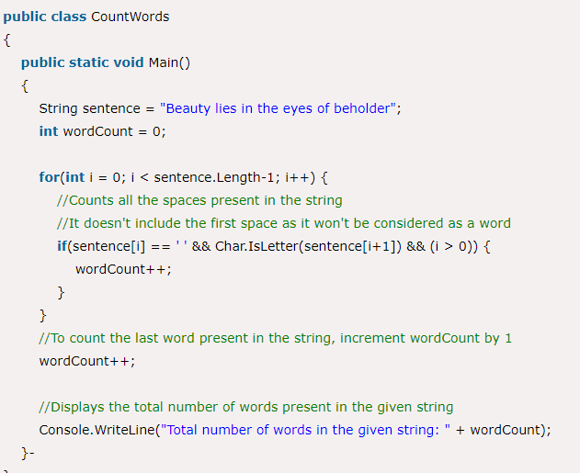

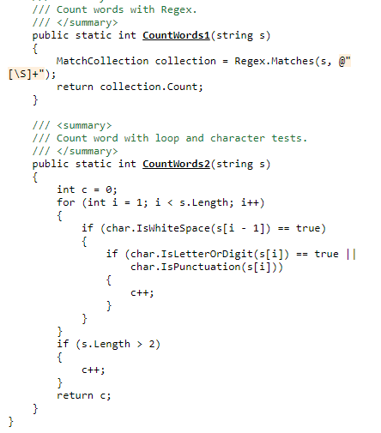

### Find closest number in array

<https://www.geeksforgeeks.org/find-closest-number-array/>

Given an array of sorted integers. We need to find the closest value to the given number. Array may contain duplicate values and negative numbers.

**Examples:**

Input : int[] = {1, 2, 4, 5, 6, 6, 8, 9}

Target number = 11

Output : 9

9 is closest to 11 in given array

Input :int[] = {2, 5, 6, 7, 8, 8, 9};

Target number = 4

Output : 5

|  |  |  |
| --- | --- | --- |
| // C# program to find element  // closet to given target.  using System;    class GFG  {        // Returns element closest      // to target in arr[]      public static int findClosest(int []arr,                                    int target)      {          int n = arr.Length;            // Corner cases          if (target <= arr[0])              return arr[0];          if (target >= arr[n - 1])              return arr[n - 1];            // Doing binary search          int i = 0, j = n, mid = 0;          while (i < j)          {              mid = (i + j) / 2;                if (arr[mid] == target)                  return arr[mid];                /* If target is less              than array element,              then search in left */              if (target < arr[mid])              {                    // If target is greater                  // than previous to mid,                  // return closest of two                  if (mid > 0 && target > arr[mid - 1])                      return getClosest(arr[mid - 1],                                   arr[mid], target);                    /* Repeat for left half */                  j = mid;              }                // If target is              // greater than mid              else              {                  if (mid < n-1 && target < arr[mid + 1])                      return getClosest(arr[mid],                           arr[mid + 1], target);                  i = mid + 1; // update i              }          }            // Only single element          // left after search          return arr[mid];      }        // Method to compare which one      // is the more close We find the      // closest by taking the difference      // between the target and both      // values. It assumes that val2 is      // greater than val1 and target      // lies between these two.      public static int getClosest(int val1, int val2,                                   int target)      {          if (target - val1 >= val2 - target)              return val2;          else              return val1;      }        // Driver code      public static void Main()      {          int []arr = {1, 2, 4, 5,                       6, 6, 8, 9};          int target = 11;          Console.WriteLine(findClosest(arr, target));      }  } LINQ,EF AND c# FUNCTIONS & collectionsWhat is anonymous type in C#? In C#, an anonymous type is a type (class) without ***any name/method signature*** that can  contain ***public read-only properties only***. It cannot contain other members, such as fields,  methods, events, etc.  You create an anonymous type using the *new* operator with an [object initializer](https://www.tutorialsteacher.com/csharp/csharp-object-initializer) syntax.  The [implicitly typed variable- var](https://www.tutorialsteacher.com/csharp/csharp-var-implicit-typed-local-variable) is used to hold the reference of anonymous types.  var student = new { Id = 1, FirstName = "James", LastName = "Bond" };  var students = from s in studentList  select new { Id = s.StudentID, Name = s.StudentName };  **Anonymous types** provide a convenient way to encapsulate a set of read-only properties into a single  object without having to explicitly define a **type** first. The **type** name is generated by the compiler and  is not available at the source code level. The **type** of each property is inferred by the compiler. What are lambda expressions in C#? **A lambda expression** is a convenient way of defining an anonymous (unnamed) function that can be passed  around as a variable or as a parameter to a method call. Many LINQ methods take a function (called a delegate)  as a parameter. Lambda expressions are how anonymous functions are created. Lambda expressions  are anonymous functions that contain expressions or sequence of operators. **All lambda expressions  use the lambda operator =>, that can be read as “goes to” or “becomes*”. The left side of the lambda  operator specifies the input parameters and the right side holds an expression or a code block that***  ***works with the entry parameters*** Expression Lambdas Parameter => expressionParameter-list => expressionCount => count + 2;Sum => sum + 2;n => n % 2 == 0  *The lambda operator => divides a lambda expression into two parts. The left side is the input parameter and the right side is the lambda body*  list.FindAll(x => (x % 2) == 0)  dogs.Select(x => **new** { Age = x.Age, FirstLetter = x.Name[0] });  dogs.OrderByDescending(x => x.Age);  <https://www.c-sharpcorner.com/UploadFile/dacca2/lambda-expression-in-15-minutes/> Why anonymous types are better than tuples ?        What are the three types of Generic delegates in C#? three types of generic delegates in C# - 1) Func 2) Action 3) Predicate  <https://www.c-sharpcorner.com/article/delegates-action-vs-func-vs-predicate2/> Action is a delegate, it can be used to point a method that has no return type. (i.e. return type will be void.)   1. **static** **void** Main(**string**[] args) 2. { 3. Action<**string**> log = **new** Action<**string**>(LogInfo); 4. log.**Invoke**("Hi ALL"); 5. Console.ReadLine(); 7. } 9. **static** **void** LogInfo(**string** message) 10. { 11. Console.WriteLine(message); 12. }  Func   Func is a delegate, we can define type(s) of input params, and at the end, we can write the output param type.   1. **static** **void** Main(**string**[] args) 2. { 3. Func<**int**, **int**, **int**> addFunc = **new** Func<**int**, **int**, **int**>(Add); 4. **int** result = addFunc(3, 4); 5. Console.WriteLine(result); 6. Console.ReadLine(); 8. } 9. **static** **int** Add(**int** a, **int** b) 10. { 11. **return** a + b; 12. }  Predicate   Predicate will always return bool, which accepts any type of parameter as its input.   1. **static** **void** Main(**string**[] args) 2. { 3. Predicate<**int**> IsEven = **new** Predicate<**int**>(IsEvenNumber); 4. Console.WriteLine(IsEven(10)); 5. Console.WriteLine(IsEven(1567)); 6. Console.ReadLine(); 8. } 9. **static** **bool** IsEvenNumber(**int** number) 10. { 11. **return** number % 2 == 0; 12. }  What is IEnumerable in C#?   IEnumerable in C# is an interface that defines one method, GetEnumerator which returns an IEnumerator interface. This *allows readonly access to a collection* then a collection that implements IEnumerable can be used with a for-each statement.   Key Points  1. IEnumerable interface contains the System.Collections.Generic namespace. 2. IEnumerable interface is a generic interface which allows looping over generic or non-generic lists. 3. IEnumerable interface also works with linq query expression. 4. IEnumerable interface Returns an enumerator that iterates through the collection.   <https://www.c-sharpcorner.com/UploadFile/0c1bb2/ienumerable-interface-in-C-Sharp/>  C# yield Example:Use the yield keyword to implement IEnumerable.  *Return elements that are used in foreach.*  The function returns an object that implements the IEnumerable<object> interface. If a calling function starts foreaching over this object, the function is called again until it "yields". This is syntactic sugar introduced in **C# 2.0**. In earlier versions you had to create your own IEnumerable and IEnumerator objects to do stuff like this.  The easiest way understand code like this is to type-in an example, set some breakpoints and see what happens. Try stepping through this example:  public void Consumer()  {  foreach(int i in Integers())  {  Console.WriteLine(i.ToString());  }  }  public IEnumerable<int> Integers()  {  yield return 1;  yield return 2;  yield return 4;  yield return 8;  yield return 16;  yield return 16777216;  }  When you step through the example, you'll find the first call to Integers() returns 1. The second call returns 2 and the line yield return 1 is not executed again.  Here is a real-life example:  public IEnumerable<T> Read<T>(string sql, Func<IDataReader, T> make, params object[] parms)  {  using (var connection = CreateConnection())  {  using (var command = CreateCommand(CommandType.Text, sql, connection, parms))  {  command.CommandTimeout = dataBaseSettings.ReadCommandTimeout;  using (var reader = command.ExecuteReader())  {  while (reader.Read())  {  yield return make(reader);  }  }  }  }  } **Q& A** **1) Explain what is LINQ? Why is it required?**  Language Integrated Query or LINQ is the collection of standard query operators which provides query facilities into.NET framework language like C#, VB.NET.  LINQ is required as it bridges the gap between the world of data and world of objects.  **4) List out the three main components of LINQ? Explain what is the extension of the file, when LINQ to SQL is used?**  Three main components of LINQ are   * Standard Query Operators * Language Extensions * LINQ Providers   **Define what is Where clause and Let clause?**   * **Where clause**: It allows adding some conditional filters to the query. * **Let clause**: It allows defining a variable and assigning it a value calculated from the data values.   **Explain why SELECT clause comes after FROM clause in LINQ?**  With other programming language and C#, LINQ is used, it requires all the variables to be declared first.  “FROM” clause of LINQ query defines the range or conditions to select records. So, FROM clause must  appear before SELECT in L   * **8) Explain what is lambda expressions in LINQ?** * Lambda expression is referred as a unique function use to form delegates or expression tree types, where right side is the output and left side is the input to the method. For writing LINQ queries particularly, Lambda expression is used. * **9) Explain how LINQ with databases can be used?** * LINQ supports XML, SQL, Dataset and Objects. Through LINQ to objects or LINQ to Datasets one can use LINQ with other databases.   **Explain what is the difference between Skip() and SkipWhile() extension method?**   * **Skip()** **:** It will take an integer argument and from the given IEnumerable it skips the top n numbers * **SkipWhile ():** It will continue to skip the elements as far as the input condition is true. It will return all remaining elements if the condition is false   [Take()](https://msdn.microsoft.com/en-us/library/bb503062%28v=vs.110%29.aspx)**method**  The Take() method extracts the first n elements (where n is a parameter to the method) from the beginning of the target sequence and returns a new sequence containing only the elements taken.  List**<int>** numbers = new List**<int>()** **{**1, 2, 3, 4, 5, 6, 7, 8, 9, 10 **}**;  List**<int>** ResultQS = **(from** num in numbers  **select** num**)**.Take**(**4**)**.ToList**()**;  **foreach(**var num in ResultQS**)**  **{**  Console.Write**(**$"{num} "**)**;  **}**  **Output: 1 2 3 4**  What is the difference between First() and Take(1)?  The difference between First() and Take() is that First() returns the element itself, while Take() returns a sequence of elements that contains exactly one element. (If you pass 1 as the parameter).  **In LINQ how will you find the index of the element using where () with Lambda Expressions?**   * In order to find the index of the element using where () with the lambda expression * Where ( ( i, ix ) => i == ix);   Mention what is the role of DataContext classes in LINQ?  DataContext class acts as a bridge between SQL Server database and the LINQ to SQL. For accessing the database and also for changing the data in the database, it contains connections string and the functions.  Essentially a DataContext class performs the following three tasks:   * *Create connection to database.* * *It submits and retrieves object to database.* * *Converts objects to SQL queries and vice versa.* * **15) Explain what are LINQ query expressions?** * Query expression is nothing but an LINQ query. It is a combination of query clauses that identifies the data sources for a query. It contains information for sorting, filtering, grouping or joining to apply to the source data. It determines what information should be retrieved from the data source.CV.   **16) Explain what are compiled queries?**  In compiled LINQ queries, the plan is cached in a static class and static class is a global cache. Rather than preparing the query plan from scratch, LINQ prepares plan using stating class object.  **17) Explain how standard query operators useful in LINQ?**  Standard Query Operators useful in LINQ are   * Get a total count of elements in the collection * Order the results of a collection * Grouping * Computing average * Joining two collections based on matching keys * Filter the results   **18) Explain what is the purpose of LINQ providers in LINQ?**  LINQ providers are set of classes that take an LINQ query which generates method that executes an equivalent query against a particular data source.  **21) Explain what is “LINQ to Objects”?**  When LINQ queries any IEnumerable(Of T) collection or IEnumerable directly without the use of an intermediate LINQ provider or API such as LINQ to SQL or LINQ to XML is referred as “LINQ to Objects.”  What are the types of LINQ?  Answer   * LINQ to Objects * LINQ to XML * LINQ to Dataset * LINQ to SQL * LINQ to Entities   What are Anonymous Types?  Anonymous types are types that are *generated by compiler at run time*. When we create a anonymous type we do not specify a name. We just write properties names and their values. Compiler at runtime create these properties and assign values to them.  var k = new { FirstProperty = "value1", SecondProperty = "value2" };  Console.WriteLine(k.FirstProperty);  Anonymous class is useful in LINQ queries to save our intermediate results.  There are some restrictions on Anonymous types as well:   * *Anonymous types cannot implement interfaces.* * *Anonymous types can not specify any methods.* * *We cannot define static members.* * *All defined properties must be initialized.* * *We can only define public fields.*  C# - Anonymous Method As the name suggests, an anonymous method is a method without a name. Anonymous methods in C# can be defined using the delegate keyword and can be assigned to a variable of delegate type.  public delegate void Print(int value);  static void Main(string[] args)  {  Print print = delegate(int val) {  Console.WriteLine("Inside Anonymous method. Value: {0}", val);  };  print(100);  }  *Anonymous methods can access variables defined in an outer function*  *Anonymous methods can also be passed to a method that accepts the delegate as a parameter.*  public delegate void Print(int value);  class Program  {  public static void PrintHelperMethod(Print printDel,int val)  {  val += 10;  printDel(val);  }  static void Main(string[] args)  {  PrintHelperMethod(delegate(int val) { Console.WriteLine("Anonymous method: {0}", val); }, 100);  }  }  Example: Anonymous Method as Event Handler  saveButton.Click += delegate(Object o, EventArgs e)  {  System.Windows.Forms.MessageBox.Show("Save Successfully!");  };  Anonymous Method Limitations   * It cannot contain jump statement like goto, break or continue. * It cannot access ref or out parameter of an outer method. * It cannot have or access unsafe code. * It cannot be used on the left side of the is operator.   https://www.tutorialsteacher.com/Content/images/bulb-glow.png Points to Remember :   1. *Anonymous method can be defined using the delegate keyword* 2. *Anonymous method must be assigned to a delegate.* 3. *\*\*\* Anonymous method can access outer variables or functions. We can use delegates  technique to invoke the function/method outside the class Ex: print looping current value in some other function* 4. *Anonymous method can be passed as a parameter.* 5. *Anonymous method can be used as event handlers.*   **ENTITY FRAMEWORK ORM (EF, L2SQL, ADO.NET):**  (++)   * Rapid development * Data access code now under source control * You're isolated from changes in DB. If that happens you only need to update your model/mappings  in one place. * Easy to add test cases * *\*\*\*Avoid Sql Injection\*\*\*\**   (--)   * Performance may be worse * No or little control over SQL the ORM produces (could be inefficient or worse buggy). Might need to intervene and replace it with custom stored procedures. That will render your code messy (some LINQ in code, some SQL in code and/or in the DB out of source control). * As any abstraction can produce "high-level" developers having no idea how it works under the hood   Could you explian what is the exact deference between deferred execution and Lazy evaluation in C#?  Answer  In practice, they mean essentially the same thing. However, it's preferable to use the term deferred.   * Lazy means "don't do the work until you absolutely have to." * Deferred means "don't compute the result until the caller actually uses it."   When the caller decides to use the result of an evaluation (i.e. start iterating through an IEnumerable<T>), that is precisely the point at which the "work" needs to be done (such as issuing a query to the database).  The term *deferred* is more specific/descriptive as to what's actually going on. When I say that I am lazy, it means that I avoid doing unnecessary work; it's ambiguous as to what that really implies. However, when I say that execution/evaluation is deferred, it essentially means that I am not giving you the real result at all, but rather a ticket you can use to claim the result. I defer actually going out and getting that result until you claim it.  Define what is Let clause?  Answer  In a query expression, it is sometimes useful to store the result of a sub-expression in order to use it in subsequent clauses. You can do this with the let keyword, which creates a new range variable and initializes it with the result of the expression you supply.  Consider:  var names = new string[] { "Dog", "Cat", "Giraffe", "Monkey", "Tortoise" };  var result =  from animalName in names  let nameLength = animalName.Length  where nameLength > 3  orderby nameLength  select animalName;  Explain what are LINQ compiled queries?  **[LINQ](https://www.fullstack.cafe/interview-questions/linq" \o "LINQ Interview Questions)**[38](https://www.fullstack.cafe/interview-questions/linq" \o "LINQ Interview Questions)  Answer  There may be scenario where we need to execute a particular query many times and repeatedly. LINQ allows us to make this task very easy by enabling us to create a query and make it compiled always. Benefits of Compiled Queries:   * Query does need to compiled each time so execution of the query is fast. * Query is compiled once and can be used any number of times. * Query does need to be recompiled even if the parameter of the query is being changed.   Consider:  static class MyCompliedQueries {  public static Func <DataClasses1DataContext, IQueryable <Person>> CompliedQueryForPerson =  CompiledQuery.Compile((DataClasses1DataContext context) = >from c in context.Persons select c);  }  When to use First() and when to use FirstOrDefault() with LINQ?  **Mid**  **[LINQ](https://www.fullstack.cafe/interview-questions/linq" \o "LINQ Interview Questions)**[38](https://www.fullstack.cafe/interview-questions/linq" \o "LINQ Interview Questions)  Answer   * Use First() when you know or expect the sequence to have at least one element. In other words, when it is an exceptional occurrence that the sequence is empty. * Use FirstOrDefault() when you know that you will need to check whether there was an element or not. In other words, when it is legal for the sequence to be empty. You should not rely on exception handling for the check. (It is bad practice and might hurt performance).   First() will throw an exception if there's no row to be returned, while FirstOrDefault() will return the default value (NULL for all reference types) instead.  enter image description here  *A select operator is used to select value from a collection* in transformed format and SelectMany operator is used to selecting values from a collection of collection i.e. nested collection.  Here is a LINQ example you can try  List<string> animals = new List<string>() { "cat", "dog", "donkey" };  List<int> number = new List<int>() { 10, 20 };  var mix = number.SelectMany(num => animals, (n, a) => new { n, a });  the mix will have following elements in flat structure like  {(10,cat), (10,dog), (10,donkey), (20,cat), (20,dog), (20,donkey)}  **What are Anonymous data types?**  Anonymous types are types that are generated by the compiler upon runtime. We don’t need to specify a name when we create an anonymous type. Only properties names are created and values assigned to them at runtime.  In LINQ, Anonymous types are used to also save intermediate results. However, Anonymous types cannot implement interfaces, specify methods, or define static methods.  All defined properties must be initialised and only public fields can be defined.  **5. What is an Anonymous function?**  An Anonymous function is a function without a name. In an Anonymous function, we only define parameters and write the code in curly braces.  **6. Explain Lambda Expression.**  Lambda expression is a shortcut to writing delegates. Lambda expression is used to write inline functions that can be passed as arguments to a function or returned as arguments from a function.  The syntax of a Lambda expression is: We specify the input parameters on the left, the lambda operator in the middle and expression or statement block on the right side.  **7. What is meant by Action in LINQ?**  Action refers to the general delegates belonging to the base class library of .NET. We can store only methods with input parameters and **void return types in Action. Upto 16 parameters** can be specified.  **12. What is PLINQ?**  PLINQ is Parallel Language Integrated Query. In PLINQ, a query can be executed using many processors. With PLINQ, Software can be made scalable across environments during execution. Apart from supporting all operators in LINQ, PLINQ also runs many LINQ queries simultaneously as well.  **13. What is the difference between the Take and Skip clause?**  The Take clause is used to return only a specified number of elements. The Skip clause on the other hand, skips a specified number of elements and returns the rest only.  How to multiply by 10 , each element of an integer Array by using LINQ ?  int[] number = { 1, 2, 3, 4, 5 };var result = number.Select(n => n * 10);foreach (var item in result){Console.WriteLine(item);}  class Program{static void Main(string[] args){int[] mynumber = { 1,2,3,4,5,6,7,8,9,10};mynumber = mynumber.Select(b => b * 10).ToArray();for (int i = 0; i < 10; i++){Console.Write(mynumber[i]);Console.WriteLine();}Console.ReadKey();}}  Can you provide a Example of Cross Product Join in LINQ ?  //Cross Product Join var players = new[] { "Tom", "Jay", "Mary" }.AsQueryable();IEnumerable query =from name1 in playersfrom name2 in playersselect name1 + " vs " + name2;query.Dump();  Aggregate is a declarative way of applying an accumulator function to a collection of elements. This means you can multiply or add all elements together. More complex accumulator functions can be used.    What is the difference between Count() and LongCount extension methods in LINQ?  1-LongCount() has a greater range than Count(). long.MinValue = -9223372036854775808 long.MaxValue = 9223372036854775807 DotNet Framework type is System.Int64 2-While count() DotNet Framework type is System.Int32 long.MinValue = -2,147,483,648 long.MaxValue = 2,147,483,647 3-So, if you want to count something which is quite big then use LongCount() extension method otherwise use Count()  How we can truncate a table Using LINQ?  EmpDataContext empobj= new EmpDataContext (); empobj.ExecuteCommand("TRUNCATE TABLE TABLENAME");  How to Fetch Different Values in LINQ?  Example:var Query= from i in db.tbl select new{i.id,i.name....}; LINQ – Lambda Expression vs Query Expression A **lambda** expression is a convenient way of defining an anonymous (unnamed) function that can be passed around as a variable or as a parameter to a method call. Many **LINQ** methods take a function (called a delegate) as a parameter. ... The => operator is called the "**lambda** operator".  As you’re probably aware of already, LINQ comes in two flavours – using Lambda expressions and using SQL-like query expressions:   |  |  | | --- | --- | |  | Func<int, bool> isEven = i => i % 2 == 0;  int[] ints = new int[] { 1, 2, 3, 4, 5, 6, 7, 8, 9 };    // using Query expression  var evensQuery = from i in ints where isEven(i) select i;  // using Lambda expression  var evensLambda = ints.Where(isEven); |   Both yields the same result because query expressions are translated into their lambda expressions before they’re compiled. So performance-wise, there’s no difference whatsoever between the two.  Which one you should use is mostly personal preference, many people prefer lambda expressions because they’re shorter and more concise, but personally I prefer the query syntax having worked extensively with SQL. With that said, it’s important to bear in mind that there are situations where one will be better suited than the other.  // using lambda expression      var lambda = people.Join(pets,              // outer sequence                               person => person,  // inner sequence key                               pet => pet.Owner,  // outer sequence key                               (person, pet) =>                                   new { OwnerName = person.Name, Pet = pet.Name });        // using query expression      var query = from person in people                  join pet in pets on person equals pet.Owner                  select new { OwnerName = person.Name, Pet = pet.Name };  }  There are a number of methods that are only available with the Lambda expression, Single(), Take(), Skip(), First() just to name a few. Although you can mix and match the two by calling the Lambda-only methods at the end of the query: |

# OOPS

SOLID principles

* S: Single Responsibility Principle (SRP)
* O: Open closed Principle (OSP)
* L: Liskov substitution Principle (LSP)
* I: Interface Segregation Principle (ISP)
* D: Dependency Inversion Principle (DIP

S: Single Responsibility Principle (SRP)

This means that every class, or similar structure, in your code should have only one job to do. Everything in that class should be related to a single purpose. Ex: The SendEmail and ValidateEmail methods have nothing to do within the UserService class.

O: Open/Closed Principle

The Open/closed Principle says "A software module/class is open for extension and closed for modification".

 Here "Open for extension" means, we need to design our module/class in such a way that the new functionality can be added only when new requirements are generated. "Closed for modification" means we have already developed a class and it has gone through unit testing. We should then not alter it until we find bugs. As it says, a class should be open for extensions, *we can use inheritance to do this*.

L: Liskov Substitution Principle

This principle is just an extension of the Open Closed Principle and it means that we must ensure that new derived classes extend the base classes without changing their behavior.Child calss should be substutable for parent ex brand car shoulbe substutiable for car feature class. Only if use interface inhertiance this principle can be applied , class inheritence doesn’t apply LSP principle

I: Interface Segregation Principle (ISP)/multiple interface inheritance

The Interface Segregation Principle states "that clients should not be forced to implement interfaces they don't use. Instead of one fat interface, many small interfaces are preferred based on groups of methods, each one serving one sub module.".

## .D: Dependency Inversion Principle

The Dependency Inversion Principle (DIP) states that high-level modules/classes should not depend on low-level modules/classes. Both should depend upon abstractions. Secondly, abstractions should not depend upon details. Details should depend upon abstractions.

**IOC & Dependency Injection**

IOC can be done using **Dependency Injection** (DI). It explains how to inject the concrete implementation into a class that is using abstraction, in other words an interface inside. The main idea of dependency injection is to reduce the coupling between classes and move the binding of abstraction and concrete implementation out of the dependent class.

In Simple words, DI is how one object knows about other dependent object which is abstracted.

There are mainly 4 ways of achieving the Dependency Injection.

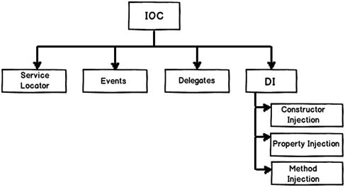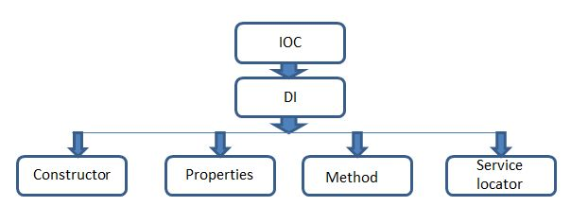

**Injection via Constructor,** **Property,** **Method**

**Advantages of implementing this principle**

* It helps in class decoupling.
* Due to decoupling, the reusability of the code is increased.
* Improved code maintainability and testing.

****Most importantly on TDD this principle improves testability and must to use***

***Inversion of control (IOC) talks about who is going to initiate the call where as the Dependency Injection (DI) talks about how one object acquires dependency on other object through abstraction.***

For example, say your application has a text editor component and you want to provide spell checking. Your standard code would look something like this:

public class TextEditor {

private SpellChecker checker;

public TextEditor() {

this.checker = new SpellChecker();

}

}

What we've done here creates a dependency between the TextEditor and the SpellChecker. In an IoC scenario we would instead do something like this:

public class TextEditor {

private IocSpellChecker checker;

public TextEditor(IocSpellChecker checker) {

this.checker = checker;

}

}

In the first code example we are instantiating SpellChecker (this.checker = new SpellChecker();), which means the TextEditor class directly depends on the SpellChecker class.

In the second code example we are creating an abstraction by having the SpellChecker dependency class in TextEditor's constructor signature (not initializing dependency in class). This allows us to call the dependency then pass it to the TextEditor class like so:

SpellChecker sc = new SpellChecker(); // dependency

TextEditor textEditor = new TextEditor(sc);

Now the client creating the TextEditor class has control over which SpellChecker implementation to use because we're injecting the dependency into the TextEditor signature.

Service Locator (SL)

Service Locator is a software design pattern that also allows us to develop loosely coupled code. It implements the DIP principle and easier to use with an existing codebase as it makes the overall design looser without forcing changes to the public interface.

The Service Locator pattern introduces a locator object that objects are used to resolve dependencies means it allows you to "resolve" a dependency within a class.

# Managed code and unmanaged code in .NET

The code, which is developed in .NET framework, is known as managed code. This code is directly executed by CLR with help of managed code execution. Any language that is written in .NET Framework is managed code.

Managed code uses CLR which in turns looks after your applications by managing memory,

**Unmanaged Code**

The code, which is developed outside .NET, Framework is known as unmanaged code.

Applications that do not run under the control of the CLR are said to be unmanaged, and certain languages such as C++ can be used to write such applications, which, for example, access low - level functions of the operating system. Background compatibility with code of VB, ASP and COM are examples of unmanaged code.

Unmanaged code can be unmanaged source code and unmanaged compile code.

Unmanaged code is executed with help of wrapper classes.

Wrapper classes are of two types: **CCW (COM Callable Wrapper)** and **RCW (Runtime Callable Wrapper).**

Wrapper is used to cover difference with the help of CCW and RCW.

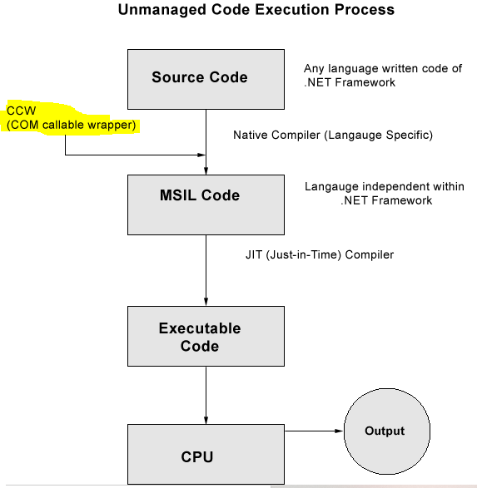

# Static Constructors

class SimpleClass

{

// Static variable that must be initialized at run time.

static readonly long baseline;

// Static constructor is called at most one time, before any

// instance constructor is invoked or member is accessed.

static SimpleClass()

{

baseline = DateTime.Now.Ticks;

}

# }

Static constructors have the following properties:

* A static constructor does not take access modifiers or have parameters.
* A class or struct can only have one static constructor.
* Static constructors cannot be inherited or overloaded.
* *A static constructor cannot be called directly and is only meant to be called by the common language runtime (CLR). It is invoked automatically.*
* The user has no control on when the static constructor is executed in the program.
* A static constructor is called automatically to initialize the [class](https://docs.microsoft.com/en-us/dotnet/csharp/language-reference/keywords/class) before the first instance is created or any static members are referenced.

### Usage

* A typical use of static constructors is when the class is using a log file and the constructor is used to write entries to this file.
* Static constructors are also useful when creating wrapper classes for unmanaged code, when the constructor can call the LoadLibrary method.
* Static constructors are also a convenient place to enforce run-time checks on the type parameter that cannot be checked at compile time via constraints (Type parameter constraints).

<https://docs.microsoft.com/en-us/dotnet/csharp/programming-guide/classes-and-structs/static-constructors>

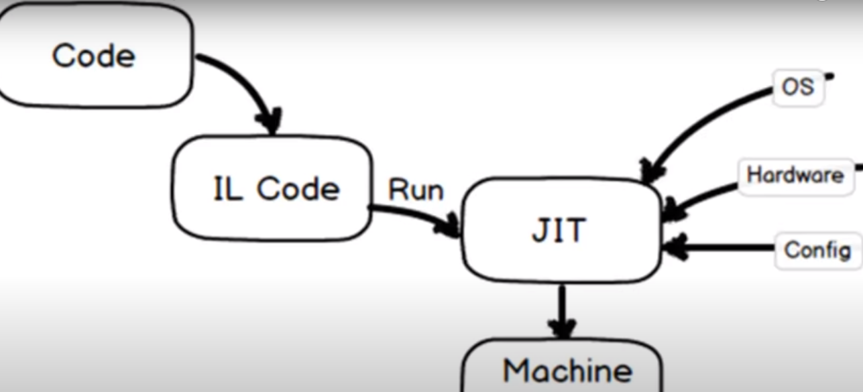

# What is Garbage Collector, Gen 0, 1 & 2?

# SQL

# Indexes in SQL Server

SQL Indexes are used in relational databases to quickly retrieve data. They are similar to indexes at the end of the books whose purpose is to find a topic quickly. SQL provides Create Index, Alter Index, and Drop Index commands that are used to create a new index, update an existing index, and delete an index in SQL Server.

* Data is internally stored in a SQL Server database in “pages” where the size of each page is 8KB.
* A continuous 8 pages is called an “Extent”.
* When we create the table then one extent will be allocated for two tables and when that extent is computed it is filled with the data then another extent will be allocated and this extent may or may not be continuous to the first extent.

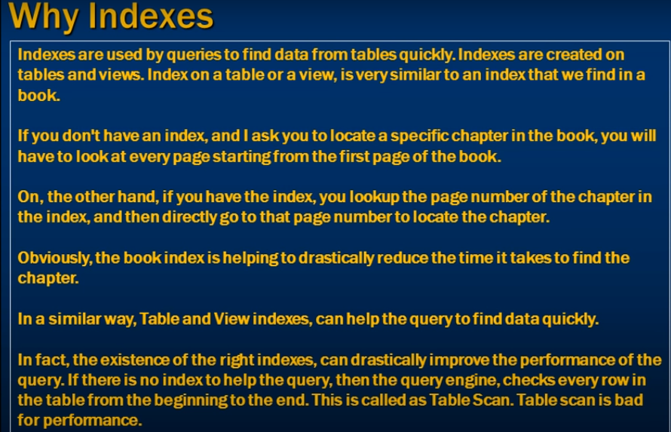

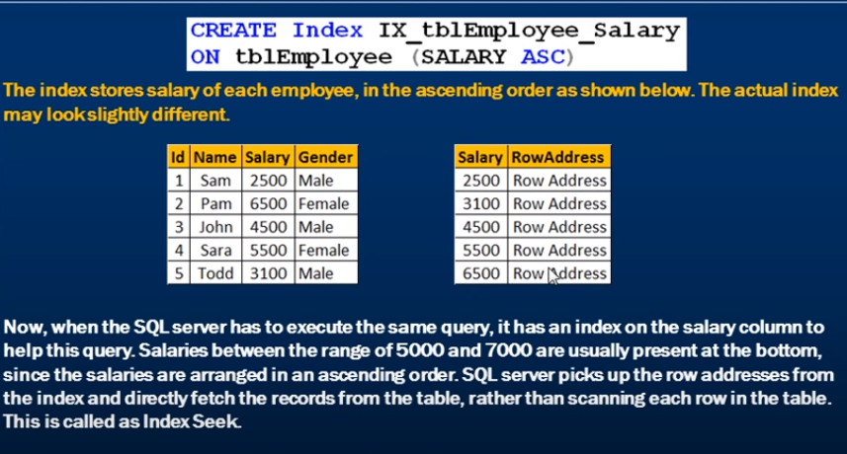

|  |  |
| --- | --- |
|  |  |

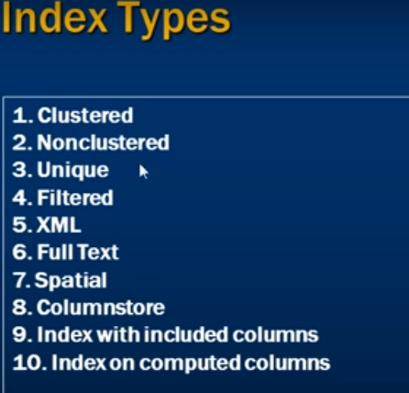

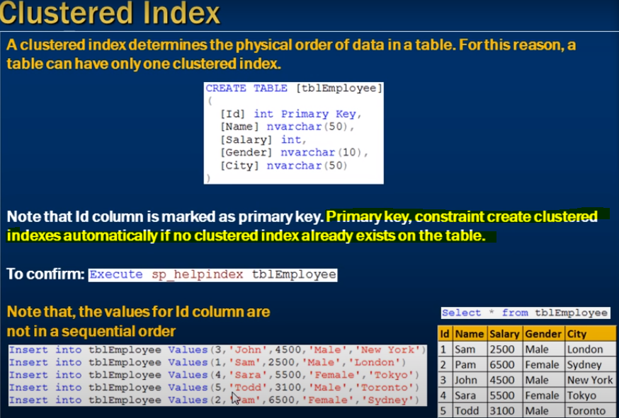

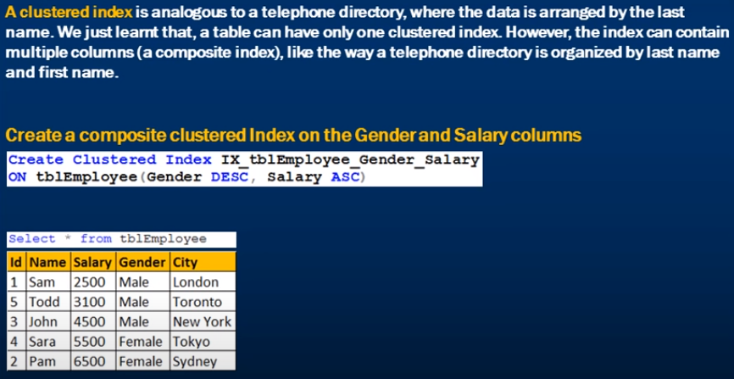

We can arragne the data in only one way hence only one cluster index

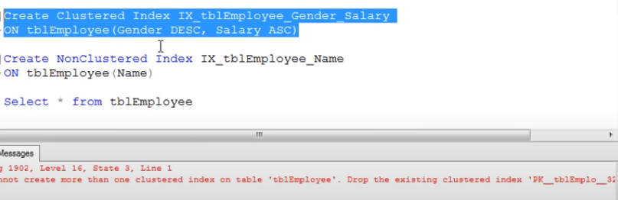

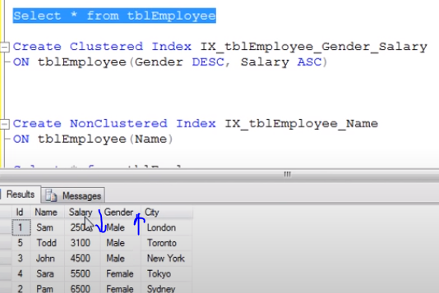

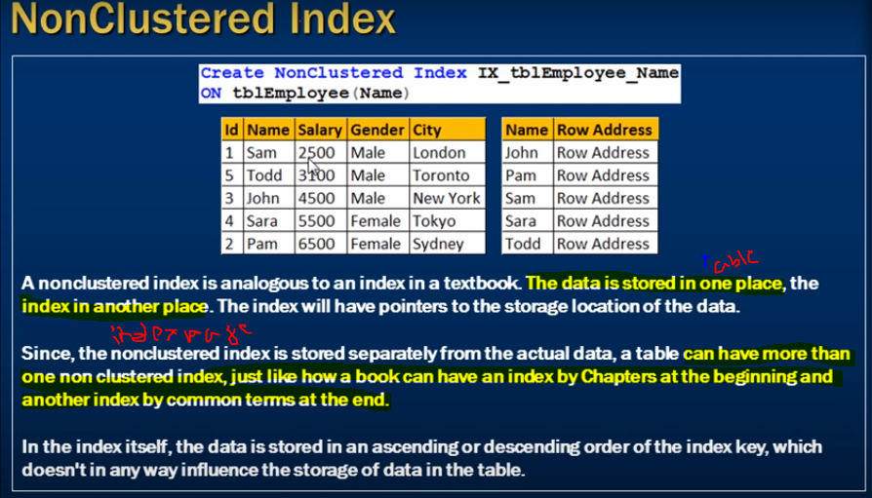

There is extra lookup is created to map the as per non cluster index , no direct imapct table data. Hence we can create many non cluster indexs and will be slower then cluster index

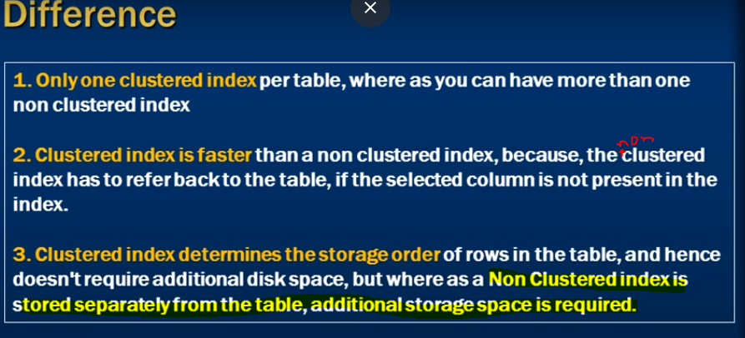

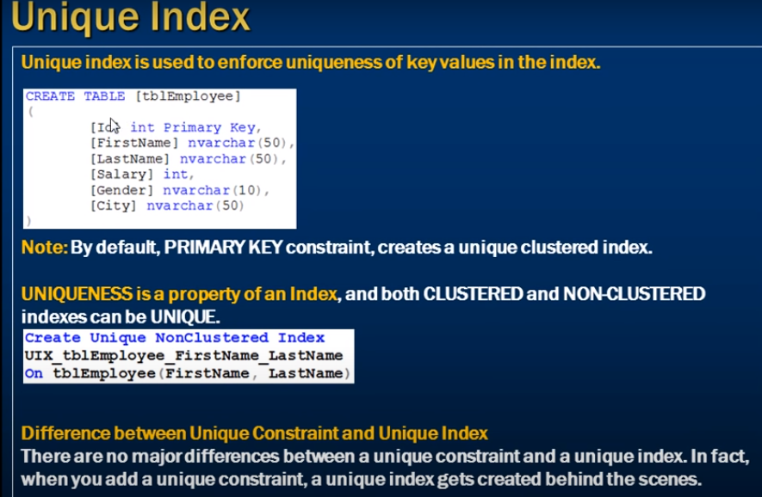

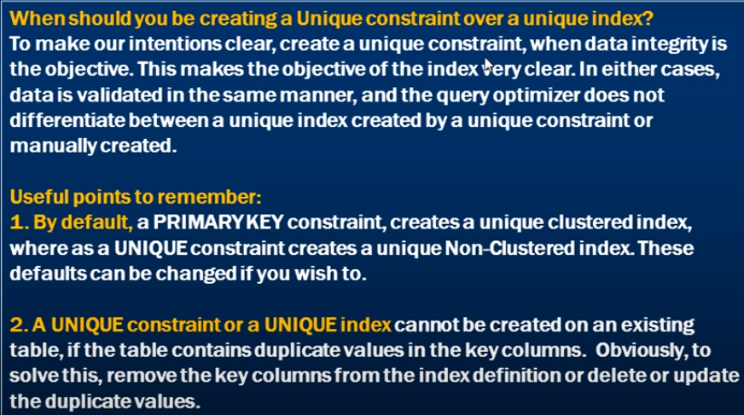

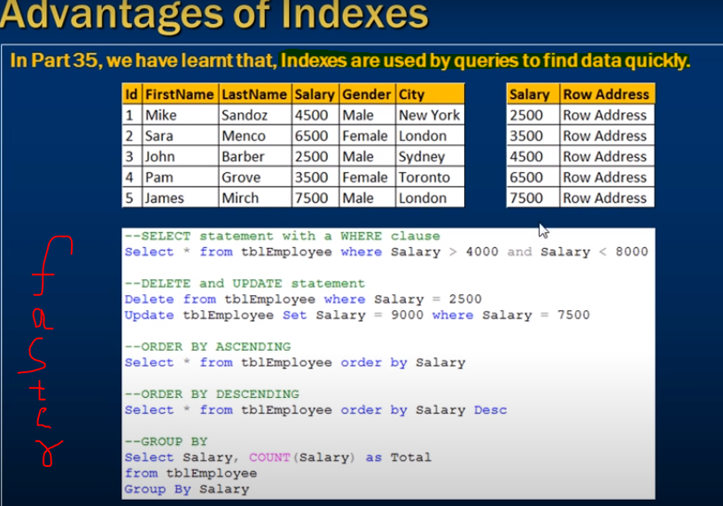

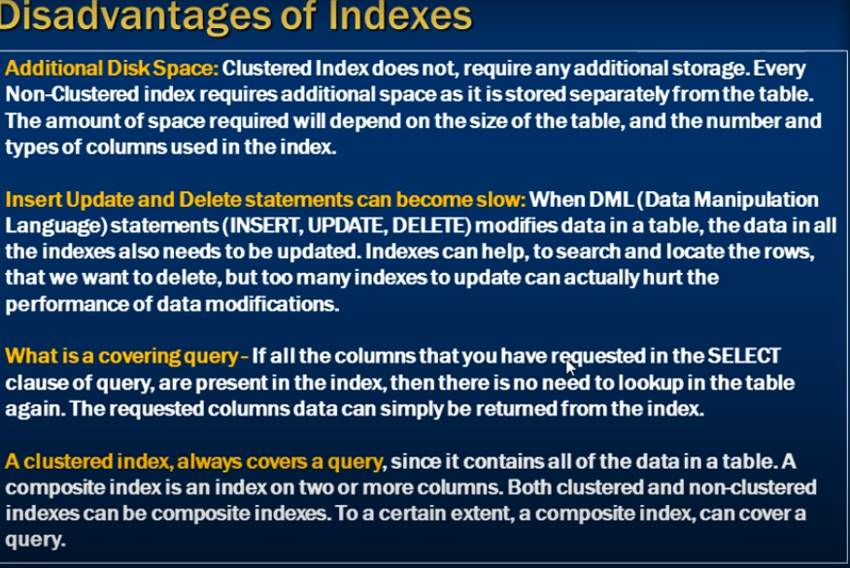

|  |  |
| --- | --- |
| Clustered Index | Non- Clustered Index |
| This will arrange the rows physically in the memory in sorted order | This will not arrange the rows physically in the memory in sorted order. |
| This will fast in searching for the range of values. | This will be fast in searching for the values that are not in the range. |
| Index for table. | You can create a maximum of 999 non clustered indexes for table. |
| Leaf node of 3 tier of clustered index contains, contains table data. | Leaf nodes of b-tree of non-clustered index contains pointers to get the contains pointers to get that contains two table data, and not the table data directly. |

<https://www.sqlshack.com/top-25-sql-interview-questions-and-answers-about-indexes/>

<https://www.c-sharpcorner.com/UploadFile/8af593/index-in-sql-server/>

# 

# 

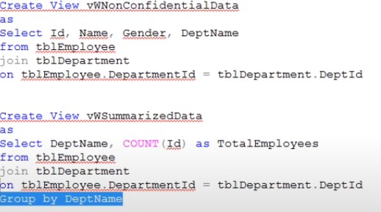

Indexs can be created on views

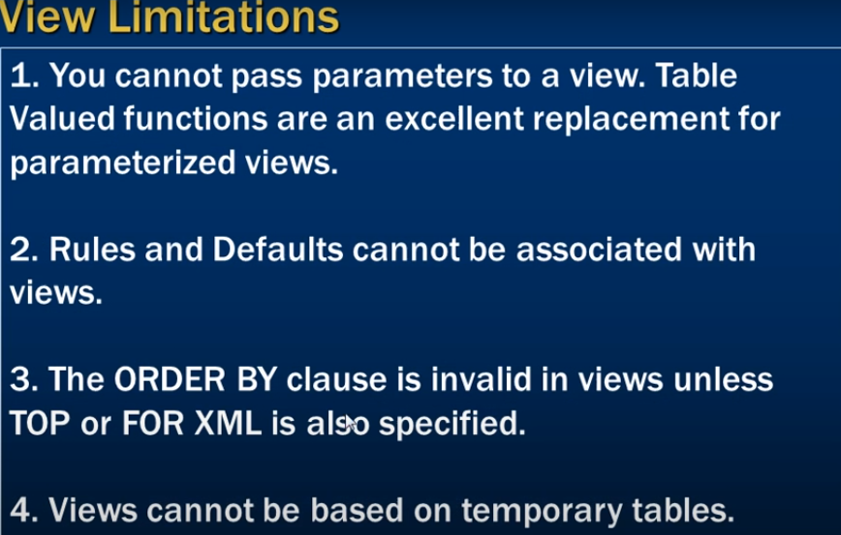

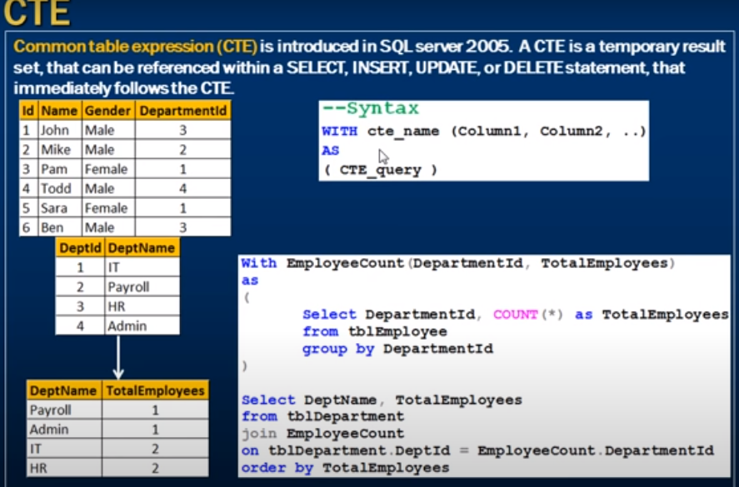



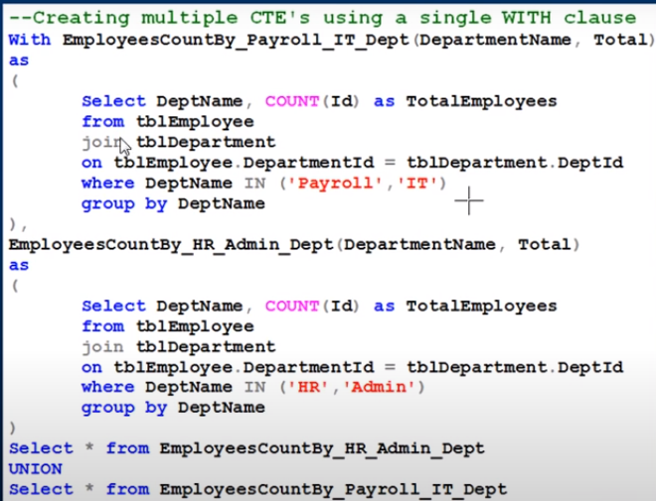

Instead of temp table use CTE for better performance

# Explain RowNumber,Partition,Rank and DenseRank ?

# 

# 

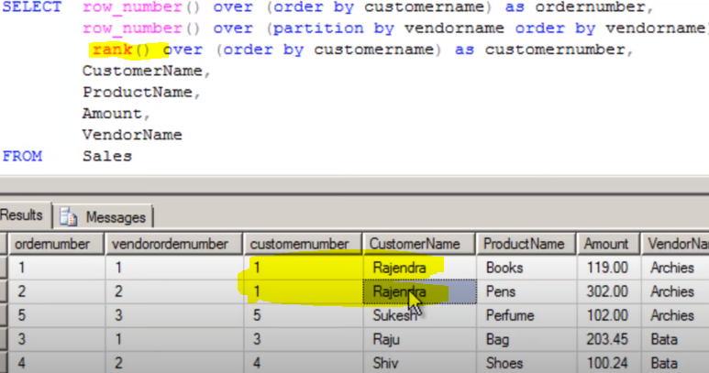

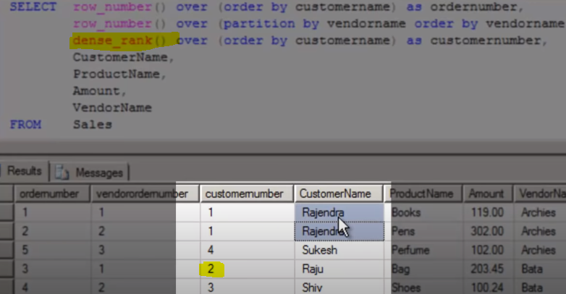

## RANK, DENSE_RANK and ROW_NUMBER functions in SQL Server

* The RANK, DENSE_RANK and ROW_NUMBER functions are used to get the increasing integer value, based on the ordering of rows by imposing ORDER BY clause in SELECT statement.
* When we use RANK, DENSE_RANK or ROW_NUMBER functions, the ORDER BY clause is required and PARTITION BY clause is optional.
* When we use PARTITION BY clause, the selected data will get partitioned, and the integer value is reset to 1 when the partition changes.

## ROW_NUMBER() Function with Partition By clause

If we want to add row number to each group, and it is reset for every group,

## Rank() Function in SQL Server

This function will assign a unique value **to each distinct** Row, but it leaves a group between the groups**.**

## Dense_Rank() Function in SQL Server

Dense_Rank() Function is similar to Rank with only difference, this will not leave gaps between groups.

### Nth Hihest salary

https://www.c-sharpcorner.com/blogs/how-to-find-highest-salary-in-sql-server

1. WITH RESULT AS
2. (
3. SELECT SALARY,
4. **DENSE_RANK()** OVER (*ORDER BY SALARY DESC*) AS DENSERANK
5. FROM EMPLOYEE
6. )
7. SELECT TOP 1 SALARY
8. FROM RESULT
9. WHERE DENSERANK = 3

# delete duplicate rows in sql

<https://www.sqlshack.com/different-ways-to-sql-delete-duplicate-rows-from-a-sql-table/>

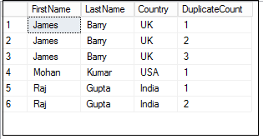

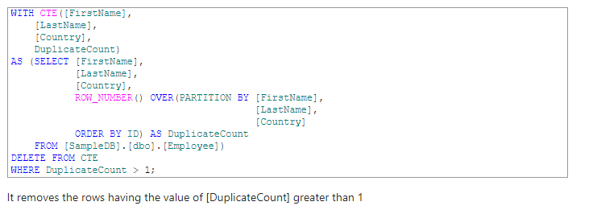

# ACID

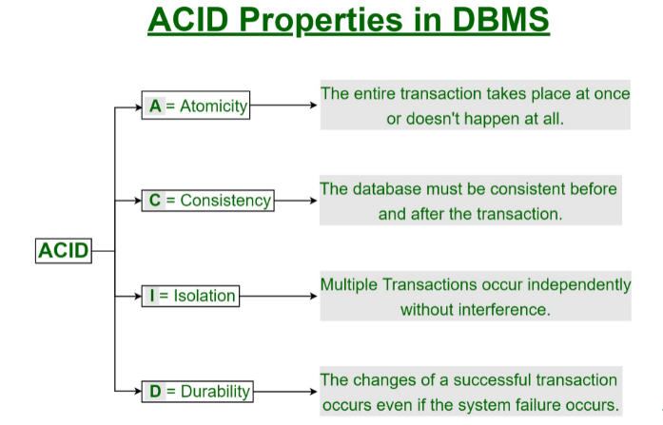

<https://www.geeksforgeeks.org/acid-properties-in-dbms/>

# What is Normalization? 1NF, 2NF, 3NF, BCNF Database Example

## What is Normalization?

**Normalization** is a database design technique that reduces data redundancy and eliminates undesirable characteristics like Insertion, Update and Deletion Anomalies. Normalization rules divides larger tables into smaller tables and links them using relationships. The purpose of Normalization in SQL is to eliminate redundant (repetitive) data and ensure data is stored logically.



<https://www.guru99.com/database-normalization.html>

<https://www.edureka.co/blog/normalization-in-sql/>

What is the opposite of 'Contains' in C#?

you can use not operator for check enter value is not in list .

1. if (!myList.Contains("name"))
2. {
3. myList.Add("name");
4. }

What is difference between the "throw" and "throw ex" in .NET?

When we use “throw” , it will throw a new exception without carrying real error info. But when we use “throw ex”, object ex will have error info like ErrorMessage from which we can identity the real reason behind this exception.  
Another scenario, if we wish to show user-friendly error message for technical exception (like Database connect issue), we can change ErroMessage property to a user-friendly message and throw that exception as “throw ex” to client.

Can we use "this" command within a static method?

No, we can’t use “this” keyword inside a static method.

“this” refers to current instance of the class. But if we define a method as static , class instance will not have access to it, only CLR executes that block of code. Hence we can’t use “this” keyword inside static method.

What is IS and AS operator in c# .NET?

Operator is used to Check the Compatibility of an Object with a given Type and it returns the result as a Boolean.

1. if(obj is int)
2. {
3. ...
4. }

As Operator is used for Casting of Object to a given Type or a Class. The as keyword is used to cast nullable types if the specified value is not an instance of the specified type.

1. AnyClass anyObject = obj as AnyClass;
2. What is Most Optimized Thread Safe Way To Lock Resources for Singleton Pattern?

Problem Statement is: the lock statement is used in case of implementing the Thread Safe Singleton Pattern.  
The question is, we need to lock a resource but using a lock(x){} statement is bit expensive as per the interviewer. What is the most efficient or optimum way to lock a resource without using lock statement?

Print 1-100 Numbers without using loop in Console Application ?

use recursive function exit when number reached to 100

1. List<int> list = Enumerable.Range(number, 100).ToList();
2. string s = string.Join(", ",list.Select(x =>x.ToString()));
3. Console.WriteLine(s);

Write a program to find an number in array of integers using Binary Search using c#

1. int[] arr = { 23, 56, 67, 78, 89, 90, 94, 95, 96, 97, 99 };
2. int key = 97;
3. int minNum = 0;
4. int maxNum = arr.Length - 1;
5. while (minNum <= maxNum)
6. {
7. int mid = (minNum + maxNum) / 2;
8. if (key == arr[mid])
9. {
10. ++mid;
11. break;
12. }
13. else if (key<arr[mid])
14. {
15. maxNum = mid - 1;
16. }
17. else
18. {
19. minNum = mid + 1;
20. }
21. }

Write a program for sorting an array of integers using c#

1. int[] numberArray = { 1, 3, 5, 67, 22, 90, 0, 6 };
2. for (int i = 0; i < numberArray.Length; i++)
3. {
4. for (int j = i; j < numberArray.Length; j++)
5. {
6. if (numberArray[i] < numberArray[j])
7. {
8. int temp = numberArray[j];
9. numberArray[j] = numberArray[i];
10. numberArray[i] = temp;
11. }
12. }
13. }
14. for (int i = 0; i < numberArray.Length; i++)
15. {
16. Console.WriteLine(numberArray[i]);
17. }
18. Console.Read();

Write a program for finding an missing number in between array of integer using c#

1. int[] array = { 1, 3, 6, 8, 14, 18 };
2. stringbuilder sbr = new stringbuilder();
3. for (int i = 0; i < array.length - 1; i++)
4. {
5. for (int j = array[i]; j < array[i + 1]; j++)
6. {
7. var temp = j + 1;
8. if (temp < array[i + 1])
9. {
10. sbr.append(temp);
11. }
12. }
13. }
14. console.writeline(sbr.tostring());
15. console.read();

///----

nt[] array = { 1, 3, 6, 8, 14, 18 };  
StringBuilder sbr = new StringBuilder();

1. for (int i = 0; i <array.Length-1; i++)
2. {
3. if (array[i] < array[i + 1])
4. {
5. int startval = array[i];
6. int endval = array[i + 1];
7. for (int j = startval+1; j < endval; j++)
8. {
9. sbr.Append( j+ " ");
10. }
11. }
12. }
13. Console.WriteLine(sbr.ToString());
14. Console.ReadKey();

Write a program for character sorting from string using c#

1. string str;
2. char[] arr1;
3. char ch;
4. int i, j, l;
5. Console.Write("\n\nSort a string array in ascending order :\n");
6. Console.Write("--------------------------------------------\n");
7. Console.Write("Input the string : ");
8. str = Console.ReadLine();
9. l = str.Length;
10. arr1 = str.ToCharArray(0, l);
11. for (i = 1; i < l; i++)
12. for (j = 0; j < l - i; j++)
13. if (arr1[j] > arr1[j + 1])
14. {
15. ch = arr1[j];
16. arr1[j] = arr1[j + 1];
17. arr1[j + 1] = ch;
18. }
19. Console.Write("After sorting the string appears like : \n");
20. foreach (char c in arr1)
21. {
22. ch = c;
23. Console.Write("{0} ", ch);
24. }
25. Console.WriteLine("\n");
26. Jul, 202014
27. **Static** a modifier used in C#. It can be used for variable, methods, classes, constructor etc. Creating static classes means that the class can only contain static properties such as static variables and static methods. We cannot create instances of static classes, it simply means that it doesn’t matter how many objects of the static class are created only one copy of the static memeber will exist.

How can you return more than one value from a method?

There are multiple ways to do it.1) by using struct/Class as return type 2) by passing parameters by ref, using out params, using tuple,…

|  |  |
| --- | --- |
| Abstract Class | Interface |
| It contains both declaration and definition part. | It contains only a declaration part. |
| ***Multiple inheritance is not achieved by abstract class.*** | *Multiple inheritance is achieved by interface*. |
| It contain [constructor](https://www.geeksforgeeks.org/c-sharp-constructors/). | It does not contain [constructor](https://www.geeksforgeeks.org/c-sharp-constructors/). |
| It can contain static members. | It does not contain static members. |
| It can contain *different types of access modifiers* like public, private, protected etc. | It only contains public access modifier because everything in the interface is public. |
| *The performance of an abstract class is fast*. | The performance of interface is slow because it requires time to search actual method in the corresponding class. |
| It is used to implement the core identity of class. | It is used to implement peripheral abilities of class. |
| A class can only use one abstract class. | A class can use multiple interface. |
| If many implementations are of the same kind and use common behavior, then it is superior to use abstract class. | If many implementations only share methods, then it is superior to use Interface. |
| Abstract class can contain methods, fields, constants, etc. | Interface can only contain methods . |
| It can be fully, partially or not implemented. | It should be fully implemented. |

C# is strong type ? C# is mostly strong type because it determines the error at compile time but some exceptions like dynamic keyword has been introduced in c# which work at run time. so it's up to us to decide even most are strong type dynamic keyword is exception.

Can we inherit an abstract class from another abstract class? public abstract class ABS1  
{  
public abstract void Read();  
}  
public abstract class ABS2:ABS1  
{  
public abstract void Write();  
}  
public class AbsChild : ABS2  
{  
public override void Read()  
{  
throw new NotImplementedException();  
}

What is the role of [Flag] attribute in enums?

The [Flags] attribute should be used whenever the enumerable represents a collection of possible values, rather than a single value. Such collections are often used with bitwise operators, for example:

[Flags]

public enum MyColors

{

Yellow = 1,

Green = 2,

Red = 4,

Blue = 8

}

var allowedColors = MyColor.Red | MyColor.Green | MyColor.Blue;

What is short-circuiting?

net run time tries to find the requested result as earliest and returns it back the caller. This is called short-circuiting.

Ex:-

if(statement 1){  
return 1;  
}  
else if( statement 2){  
return 2;  
}  
else{  
return 3;  
}

as soon as any statement expression is true , runtime returns that value as response and hence short-circuiting the request pipeline.

what is basic diff. b/w tostring() and convert.tostring()?

tostring() : returns a null reference exception convert.tostring() : returns an empty string and does not throw an exception

What will be the return type if we use .Any() in entity framework. if we will use .any in Entity Code it will always return Bool results.  
i.e It My Be **TRUE** or My Be **False**

In which of the following collections is the Input/Output index-based?

1. Stack
2. Queue
3. BitArray
4. ArrayList
5. HashTable

3&4 BitArray and ArrayList

What will be the output of the C#.NET code snippet given below?

1. string str = "Hello World!";
2. Console.WriteLine(String.Compare(str, "Hello World?").GetType());

System.Int32

What happens when the following elements get inserted in an ArrayList?

1. al.Add(1);
2. al.Add('1');
3. al.Add("1");

a) Compilation Error  
b) Code works perfectly - Prints 1 ‘1’ “1” if an Console.Write statement is written.  
c) System.IndexOutOfRangeException  
d) System.InvalidCastException  
e) System.StackOverflowException  
f) System.IO.IOException

Unlike arrays, Arraylist can have objects of different types. So it will work. b.

What will be the output of the following C# code

1. byte num = 100;
2. dynamic val = num;
3. //What will be displayed as output for-
4. Console.Writeline(val.GetType());
5. //and
6. val+=100;
7. Console.Writeline(val.GetType());

Is it possible to store mixed datatypes such as int, string, float, char, all in one array? we can use dynamic array ex- dynamic[] arr = {"abc",11,11.23 };We can do that but , Array List is the correct

In an ArrayList, if an item is added using Insert method like below- al.Insert(2, "item") What will happen to the existing item at index 2?

It will shift to the next index of that ArrayList.

Please follow the given example below

ArrayList a1 = new ArrayList();  
a1.Add(“abc”);  
a1.Add(“aa”);  
a1.Add(“baba”);

//before inserting new element  
Console.WriteLine(a1[2]);

//adding new element at 2nd index  
a1.Insert(2, “item”);

//after added  
Console.WriteLine(a1[2]);  
Console.WriteLine(a1[3]);  
//“baba” is shifted at index 3 now

Console.ReadLine();

Can DateTime be compared to null? Why or why not?

DateTime CAN be compared to null; It cannot hold null value, thus the comparison will always be false. DateTime is a "Value Type". Basically a "value type" can't set to NULL. But by making them to "Nullable" type, We can set to null. Yes, If declare DateTime variable as nullable like DateTime? then we can compare it with null.

Write the name of the three ways to pass a parameter to a method in C#.

1Value Parameters 2. Reference Parameters 3. Output Parameters

Can we inherit Static Class in C# ?

static classes are sealed classes , they can not be inherit

Can an abstract class have static methods? Yes, abstract class can have Static Methods. The reason for this is Static methods do not work on the instance of the class, they are directly associated with the class itself. So if you write a static method in the class and compile it, and when you try to view the IL, it will be same as any other class accessing the static member.

Can I Create The Constructor Of Static Class

We can create static constructor without any access modifier. We can not create parameter constructor for static class. Please try this public static class MyStaticClass{public static int i;static MyStaticClass(){i = 10;}}

Why private constructor is used ? . Private Constructor: Private Constructors are used to restrict the instantiation of object using 'new' operator.  2. It is commonly used in classes that contain static members only.  3. This type of constructors is mainly used for creating singleton object.  4. If you don't want the class to be inherited we declare its constructor private.  5. We can't initialize the class outside the class or the instance of class can't be created outside if its constructor is declared private. 6.  We have to take help of nested class (Inner Class) or static method to initialize a class having private constructor.

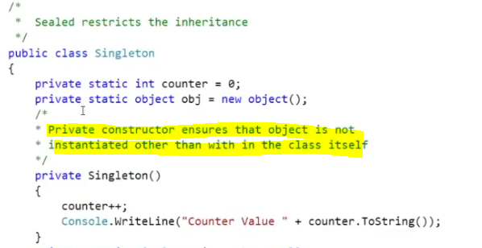

Difference between IEnumerable and Enumerable

IEnumerable is an interface. It is part of system.collection namespace and it has one method, GetEnumerator. This is the method the foreach loop uses loop through a collection and returns an IEnumerator Interface.An Enumerable class is part of Linq library and is a bunch of extension methods written for the IEnumerable interface. It has many extension methods like First, FirstorDefault, Any, Last, LastorDefault, Max, Sum, Average etc..

Can we inherit enum in C#?No, not possible. Enums cannot inherit from other enums. In fact all enums must actually inherit from System.Enum . C# allows syntax to change the underlying representation of the enum values which looks like inheritance, but in actuality they still inherit from System.enum

Can we use await in catch and finally blocks?

Yes, we can use it, from C# 6.0 onward. C# 6 was introduced with Visual Studio 2015. It supports using await in catch and finally blocks.

What is Null Design Patter in C#

<https://www.c-sharpcorner.com/article/null-object-design-pattern/>

Can you declare variable in interfaceWhen you declare a variable, it will give "Interface can not contain a field" which means you can;t declare a variable in an interface. So answer is No, we Can't.

What is the difference between sealed class and abstract class? 1)Sealed class cannot be inherited by a normal class. 1)Abstract class must be inherited by a class.2)Instance must be used for Sealed class for accessing its public methods. 2)Instance cannot be created for Abstract class and it should be inherited for accessing its abstract methods.3)Sealed class methods cannot be override. 3)Abstract class methods can be override.

what is virtual constructor? Constructors cannot be virtual. Declaring a constructor as a virtual function is a syntax error.

Is 'string' a value type or Reference type? string is reference type and default is sealed class. its does not have default allocation size. string is reference type,all primitive data types except general data type(string &object ) are value types.class, interface and delegates are reference type,in which the memory will store in heap memory.structures and enums are value type in which memory will store in stack memory

Tell me use cases of Array and Linked list? Size of array is fixed. size of linked list is dynamic

What are the fundamental differences between value types and reference types? C# divides types into two categories - value types and reference types. Most of the intrinsic types (e.g. int, char) are value types. Structs are also value types. Reference types include classes, arrays and strings. The basic idea is straightforward - an instance of a value type represents the actual data, whereas an instance of a reference type represents a pointer or reference to the data.The most confusing aspect of this for C++ developers is that C# has predetermined which types are represented as values, and which are represented as references. A C++ developer expects to take responsibility for this decision.For example, in C++ we can do this:int x1 = 3; // x1 is a value on the stack int *x2 = new int(3) // x2 is a pointer to a value on the heapbut in C# there is no control:int x1 = 3; // x1 is a value on the stack int x2 = new int(); x2 = 3; // x2 is also a value on the stack!

What’s the difference between the System.Array.CopyTo() and System.Array.Clone()?System.Array.CopyTo() is used when only we have source and destination array.This works in existing array. System.Array.Clone() is used when only we have source and not destination array.This create a new duplicate of array. The Clone() method returns a new array (a shallow copy) object containing all the elements in the original array. The CopyTo() method copies the elements into another existing array. Both perform a shallow copy. A shallow copy means the contents (each array element) contains references to the same object as the elements in the original array. A deep copy (which neither of these methods performs) would create a new instance of each element's object, resulting in a different, yet identacle object.

How do you mark a method obsolete? [Obsolete] public int Foo() {…} or [Obsolete(\”This is a message describing why this method is obsolete\”)] public int Foo() {…}

What is the difference between Finalize() and Dispose() methods? Dispose method will be used to free unmanaged resources like files, database connection etc. we need to write the code manually to call Dispose() method.It belongs IDisposable Interface.Finalize() : This method also free unmanaged resources like database connections, files etc…But Its automatically raised by Garbage Collector.This method belongs to object class. Finalize remove both live & dead objects But dispose can not

What is dynamic keyword ? dynamic is the run time bounded so it will decide the type of value on run time. its dynamic typed variable. Dynamic is a new type available in .NET to bypass compiler check during variable initialization and does it on run time.

What is the default access modifier for a Class in C#?Default access modifier of class is Internal. And private for class member.

What is the Use of a Private Constructor in C#?Private constructor are used in Singleton pattern. Private Constructor will restrict to creat the object of that class. it will leads to protect the data from that class with out accessing from another class.

C# 6.0 New Features

<https://www.codeproject.com/Articles/879887/Csharp-New-Features>

How can we pass parameters to Static Constructors? Static constructor never have parameter. static constructor is called when the execution of the class is started. It is the first member to be execute in the class. at this time how can we pass any parameters to it. if we create object of the class then it will call the non static constructor. so we can not pass any parameters into it at any cost.

LINQ – Lambda Expression vs Query Expression

A lambda expression is a convenient way of defining an anonymous (unnamed) function that can be passed around as a variable or as a parameter to a method call. Many LINQ methods take a function (called a delegate) as a parameter. ... The => operator is called the "lambda operator". What does => mean in C#?The => token is supported in two forms: as the lambda operator and as a separator of a member name and the member implementation in an expression body **definition**

As you’re probably aware of already, LINQ comes in two flavours – using Lambda expressions and using SQL-like query expressions:

|  |  |
| --- | --- |
|  | Func<int, bool> isEven = i => i % 2 == 0;  int[] ints = new int[] { 1, 2, 3, 4, 5, 6, 7, 8, 9 };    // using Query expression  var evensQuery = from i in ints where isEven(i) select i;  // using Lambda expression  var evensLambda = ints.Where(isEven); |

Both yields the same result because query expressions are translated into their lambda expressions before they’re compiled. So performance-wise, there’s no difference whatsoever between the two.

Which one you should use is mostly personal preference, many people prefer lambda expressions because they’re shorter and more concise, but personally I prefer the query syntax having worked extensively with SQL. With that said, it’s important to bear in mind that there are situations where one will be better suited than the other.

// using lambda expression

    var lambda = people.Join(pets,              // outer sequence

                             person => person,  // inner sequence key

                             pet => pet.Owner,  // outer sequence key

                             (person, pet) =>

                                 new { OwnerName = person.Name, Pet = pet.Name });

    // using query expression

    var query = from person in people

                join pet in pets on person equals pet.Owner

                select new { OwnerName = person.Name, Pet = pet.Name };

}

There are a number of methods that are only available with the Lambda expression, Single(), Take(), Skip(), First() just to name a few. Although you can mix and match the two by calling the Lambda-only methods at the end of the query:

Why to use “using” in C#? using keyword can use two places 1.) when adding a namespace 2.) dispose the object automatically when the class implement idisposable interface.

What is Nullable Types in C#? Value types can not store the null values,nullable feature added in c#2.0.now onwords we can able to add null values to value types. ex: int x=null; \\invalid int? x = null; \\ valid

C# Collections :

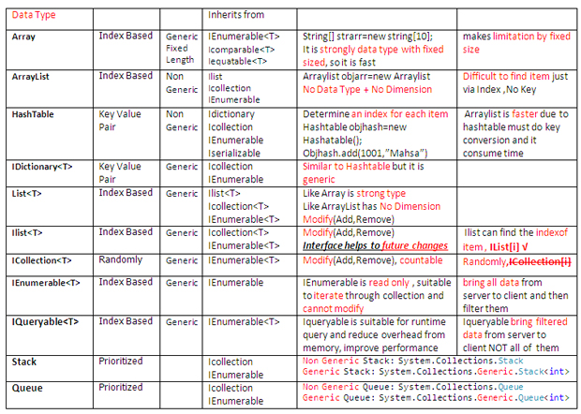

<https://www.codeproject.com/Articles/832189/List-vs-IEnumerable-vs-IQueryable-vs-ICollection-v>

***IEnumerable Vs IQueryable? Ienumerable fetches the entire data from the database.It fetches the record one by one.It can Read , but cannot modify and update the data.It is the forward only data,we cannot insert the items at the middle.IQueryable : IQueryable fetches the Record based on filter wise***. IQueryable is faster than IEnumerable. IEnumerable loads data in-memory and then apply filters to it one by one but IQueryable apply filters all at once in db and return the result.***

**IQueryable**<T> inherits from IEnumerable  IQueryable applies filter on server/database , whereas IEnumerable applies filter on client side

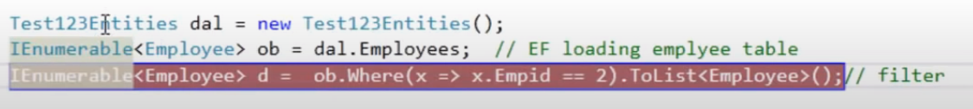

***On SQL:***

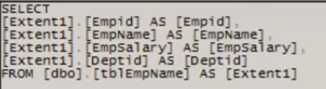

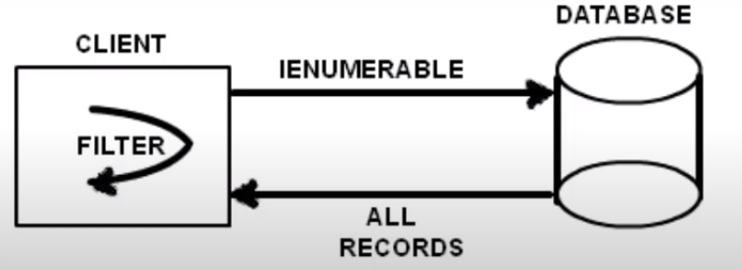

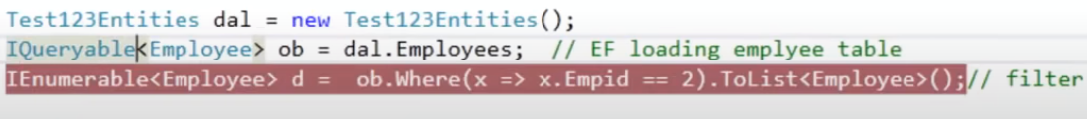

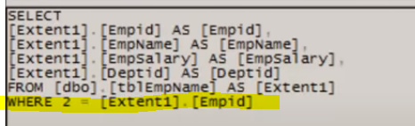

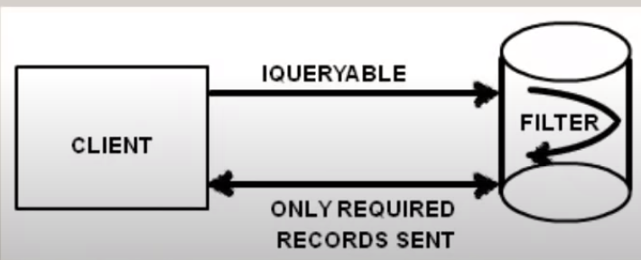



[***https://www.c-sharpcorner.com/UploadFile/a20beb/ienumerable-vs-iqueryable-in-snlinq/***](https://www.c-sharpcorner.com/UploadFile/a20beb/ienumerable-vs-iqueryable-in-snlinq/)

## Differences

**IEnumerable**

1. IEnumerable exists in the System.Collections namespace.  
     
   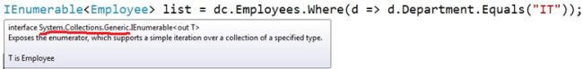
2. IEnumerable is suitable for querying data from in-memory collections like List, Array and so on.
3. While querying data from the database, IEnumerable executes "select query" on the server-side, loads data in-memory on the client-side and then filters the data.  
     
   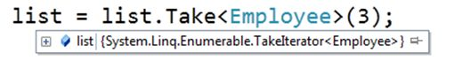
4. IEnumerable is beneficial for LINQ to Object and LINQ to XML queries.

**IQueryable**

1. IQueryable exists in the System.Linq Namespace.  
     
   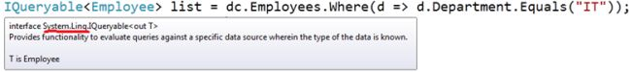
2. IQueryable is suitable for querying data from out-memory (like remote database, service) collections.
3. While querying data from a database, IQueryable executes a "select query" on server-side with all filters.  
     
   
4. IQueryable is beneficial for LINQ to SQL queries.

* IEnumerable exists in System.Collections Namespace.
* IQueryable exists in System. Linq Namespace.
* Both IEnumerable and IQueryable are forward collection.
* IEnumerable doesn’t support lazy loading
* IQueryable support lazy loading
* Querying data from a database, IEnumerable execute a select query on the server side, load data in-memory on a client-side and then filter data.
* Querying data from a database, IQueryable execute the select query on the server side with all filters.
* IEnumerable Extension methods take functional objects.
* IQueryable Extension methods take expression objects means expression tree.

.

## how to kill thread?

The reason it's hard to just kill a thread is because the language designers want to avoid the following problem: your thread takes a lock, and then you kill it before it can release it. Now anyone who needs that lock will get stuck.

What you have to do is use some global variable to tell the thread to stop. You have to manually, in your thread code, check that global variable and return if you see it indicates you should stop.

private Thread _myThread = new Thread(SomeThreadMethod);

private void SomeThreadMethod()

{

// do whatever you want

}

[SecurityPermissionAttribute(SecurityAction.Demand, ControlThread = true)]

private void KillTheThread()

{

_myThread.Abort();

}

Based on timeout

Alternative to using a Stopwatch, you could do this:

Thread thread = new Thread(new ThreadStart(delegate()

{

threadCode(o);

}));

thread.Start();

thread.Join(myTimeout);

if(thread.IsAlive)

{

thread.Abort();

}

if you're going to terminate the hanging thread by using Thread.Abort(), make sure you handle ThreadAbortException in your thread code. The normal pattern is:

try {

// do work here

}

catch (ThreadAbortException) {

// allows your thread to gracefully terminate

Thread.ResetAbort();

}

catch {

// regular exception handling

}

<https://www.geeksforgeeks.org/how-to-terminate-a-thread-in-c-sharp/>

<https://docs.microsoft.com/en-us/dotnet/api/system.threading.thread.abort?view=netframework-4.7.2>

In C#, a thread can be terminated using **Abort() method**. Abort() throws ThreadAbortException to the thread in which it called. Due to this exception, the thread is terminated. There are two methods in the overload list of Thread.Abort Method as follows:

1. **Abort()**
2. **Abort(Object)**

#### Abort()

This method raises a ThreadAbortException in the thread on which it is invoked, to begin the process of terminating the thread. Generally, this method is used to terminate the thread.

**Syntax:**

public void Abort();

**Exceptions:**

* **SecurityException**: If the caller does not have the required permission.
* **ThreadStateException**: If the thread that is being aborted is currently suspended.

// C# program to illustrate the

// concept of Abort() method

// on a single thread

using System;

using System.Threading;

class ExampleofThread {

// Non-Static method

public void thread()

{

for (int x = 0; x < 3; x++) {

Console.WriteLine(x);

}

}

}

// Driver Class

class ThreadExample {

// Main method

public static void Main()

{

// Creating instance for mythread() method

ExampleofThread obj = new ExampleofThread();

// Creating and initializing threads

Thread thr = new Thread(new ThreadStart(obj.thread));

thr.Start();

Console.WriteLine("Thread is abort");

// Abort thr thread

// Using Abort() method

thr.Abort();

}

}

**Important Points:**

* A **deadlock**can occur if the thread that calls Abort methods holds a lock that the aborted thread requires.
* If the *Abort*method is called on a thread which has not been started, then that thread will abort when Start is called.
* If the *Abort*method is called on a thread which is blocked or is sleeping then the thread will get interrupted and after that get aborted.
* If *Abort*method is called on a suspended thread then a ThreadStateException is thrown in the thread that called Abort, and *AbortRequested*is added to the *ThreadState*property of the thread being aborted.
* A *ThreadAbortException*is not thrown in the suspended thread until *Resume*is called.
* If the *Abort*method is called on a Managed thread which is currently executing unmanaged code then a ThreadAbortException is not thrown until the thread returns to managed code.
* If two calls to *Abort*come at the same time then it is possible for one call to set the state information and the other call to execute the Abort. But, an application cannot detect this situation.
* After *Abort*is called on a thread, the state of the thread includes *AbortRequested*. After the thread has terminated due to the result of a successful call to Abort, the state of the thread is changed to Stopped. With sufficient permissions, a thread which is the target of an *Abort*can cancel the abort using the *ResetAbort*method.

When and why you should use 1=1 in WHERE clause? it shows the all records from table. If you don't know  the list of conditions at compile time and it will built at run time, Then you can made a condition with “where 1=1”. and for other conditions that will affect run time, use

## Multi Threading :

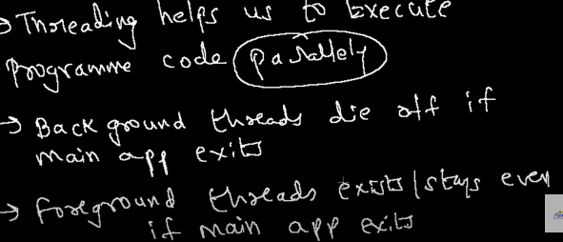

#### Foreground Thread

A thread which keeps on running to complete its work even if the Main thread leaves its process, this type of thread is known as foreground thread. Foreground thread does not care whether the main thread is alive or not, it completes only when it finishes its assigned work. Or in other words, the life of the foreground thread does not depend upon the main thread.

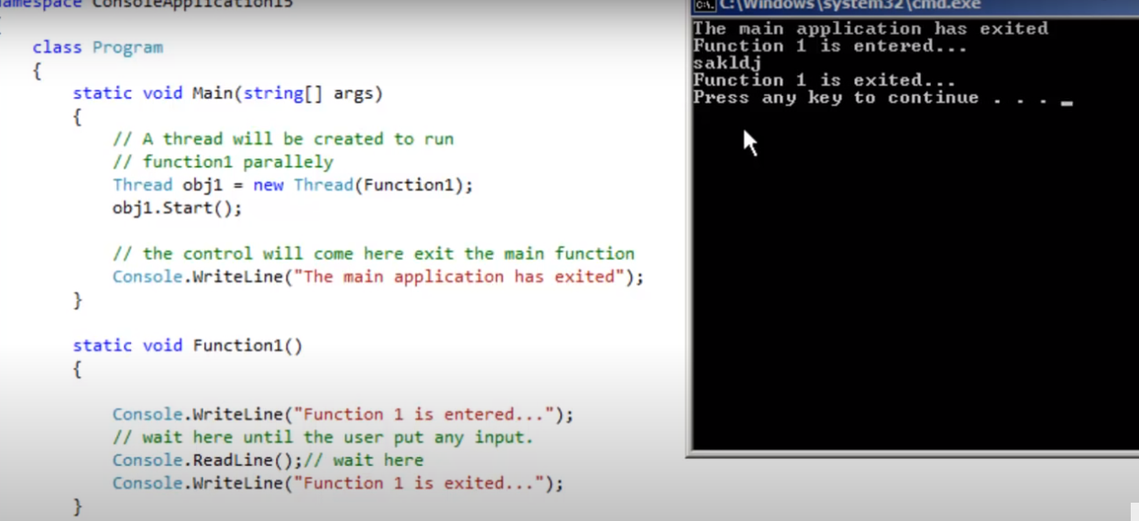

#### Background Thread

A thread which leaves its process when the Main method leaves its process, these types of the thread are known as the background threads. Or in other words, the life of the background thread depends upon the life of the main thread. If the main thread finishes its process, then background thread also ends its process.

**Note:** If you want to use a background thread in your program, then set the value of IsBackground property of the thread to true.

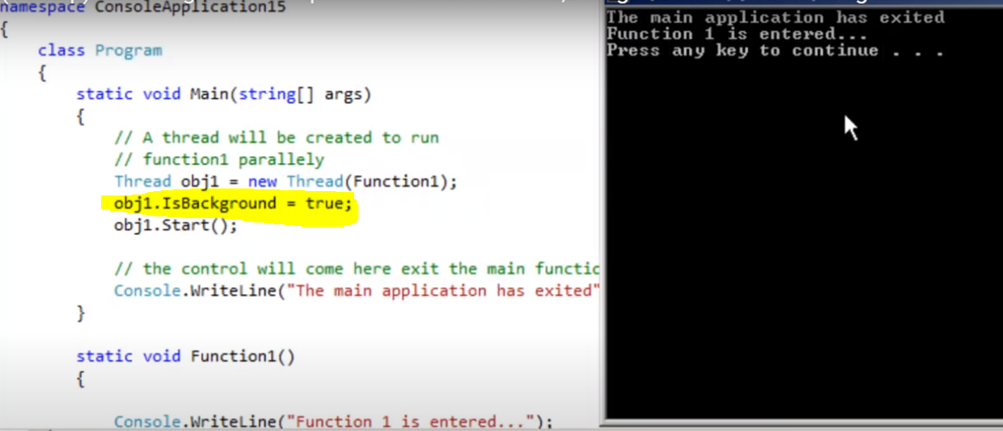

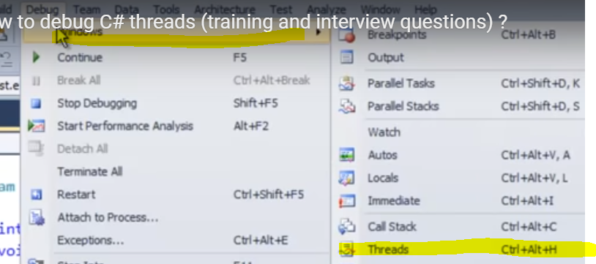

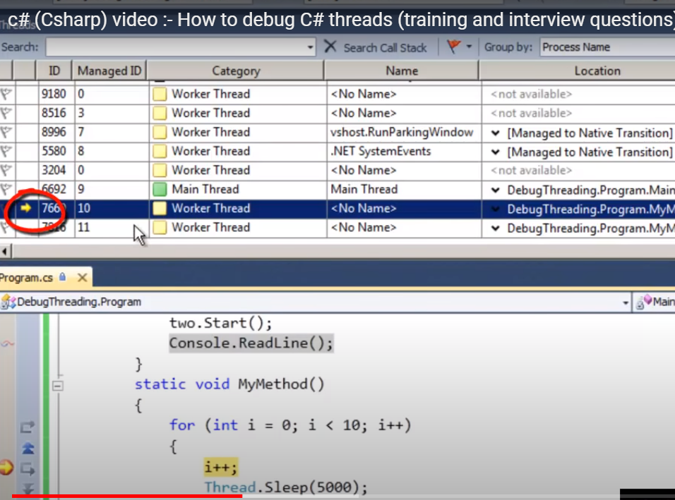

***Ideally if you do multithreading using single core its time slicing or context swiitching***

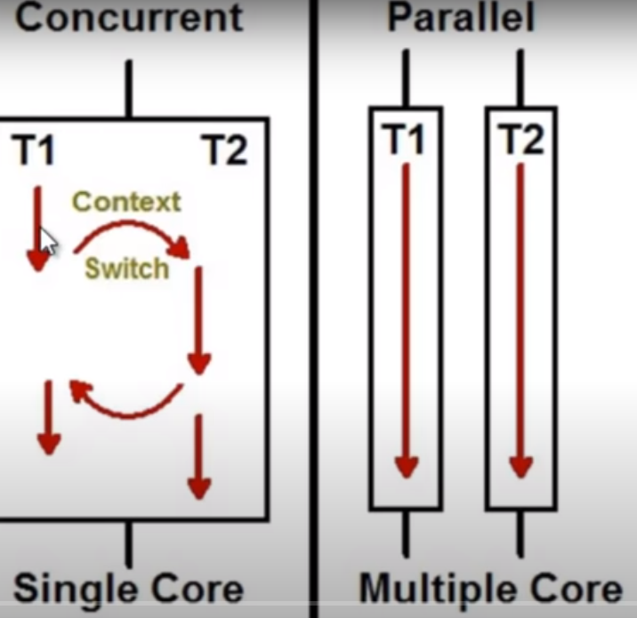

*We can use task libaray for effective usage of cores*

Does normsl thread DOES MAKE USE OF MULTI CORES ?

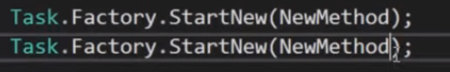



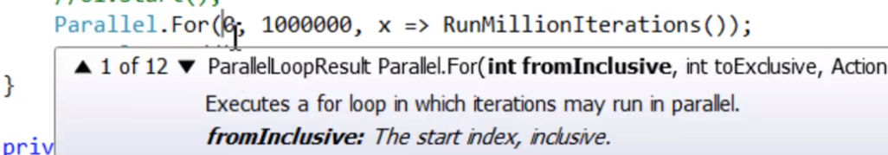

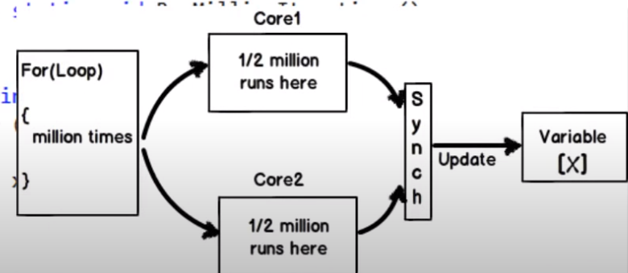

On **perform monitor tool** to verify that cores/processors are efectively utilized

|  |  |
| --- | --- |
| Before | After |

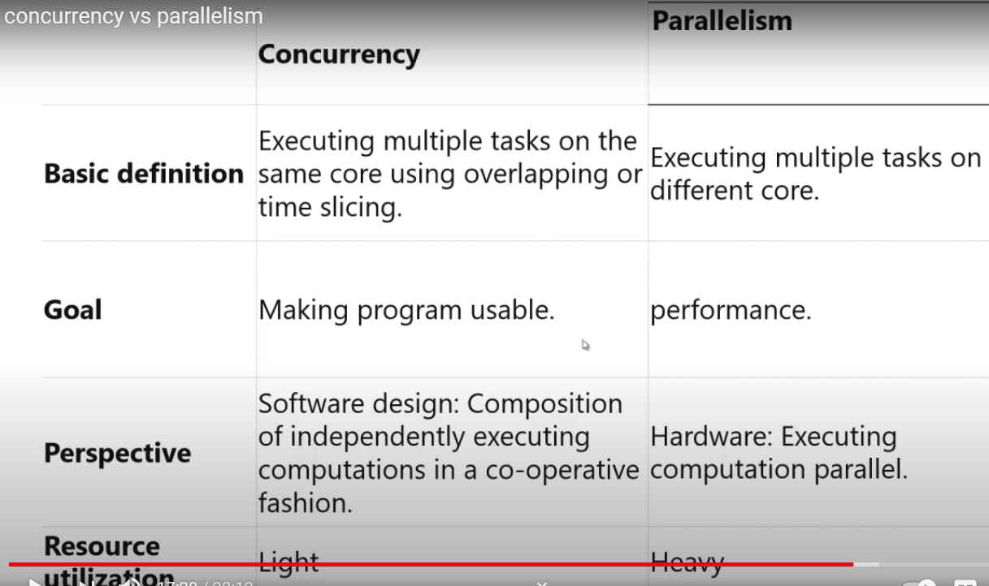

## What is Task in C#?

.NET framework provides Threading.Tasks class to let you create tasks and run them asynchronously. A task is an object that represents some work that should be done. The task can tell you if the work is completed and if the operation returns a result, the task gives you the result.

## What is Thread?

.NET Framework has thread-associated classes in System.Threading namespace.  A Thread is a small set of executable instructions.

**Why we need Tasks**

It can be used whenever you want to execute something in parallel. Asynchronous implementation is easy in a task, using’ async’ and ‘await’ keywords.

**Why we need a Thread**

When the time comes when the application is required to perform few tasks at the same time.

## Differences Between Task And Thread

## Differences between a task and a thread.

1. The Thread class is used for creating and manipulating a [thread](http://msdn.microsoft.com/en-us/library/windows/desktop/ms684841%28v=vs.85%29.aspx) in Windows. A [Task](http://msdn.microsoft.com/en-us/library/vstudio/system.threading.tasks.task) represents some asynchronous operation and is part of the [Task Parallel Library](http://msdn.microsoft.com/en-us/library/dd460717%28v=vs.110%29.aspx), a set of APIs for running tasks asynchronously and in parallel.
2. The task can return a result. There is no direct mechanism to return the result from a thread.
3. Task supports cancellation through the use of cancellation tokens. But Thread doesn't.
4. A task can have multiple processes happening at the same time. Threads can only have one task running at a time.
5. We can easily implement Asynchronous using ’async’ and ‘await’ keywords.
6. A new Thread()is not dealing with Thread pool thread, whereas Task does use thread pool thread.
7. A Task is a higher level concept than Thread.

[https://www.c-sharpcorner.com/article/task-and-thread-in-c-sharp/#:~:text=Differences%20Between%20Task%20And%20Thread,-Here%20are%20some&text=The%20Thread%20class%20is%20used%20for%20creating%20and%20manipulating%20a,tasks%20asynchronously%20and%20in%20parallel.&text=Threads%20can%20only%20have%20one%20task%20running%20at%20a%20time](https://www.c-sharpcorner.com/article/task-and-thread-in-c-sharp/#:~:text=Differences%20Between%20Task%20And%20Thread,-Here%20are%20some&text=The%20Thread%20class%20is%20used%20for%20creating%20and%20manipulating%20a,tasks%20asynchronously%20and%20in%20parallel.&text=Threads%20can%20only%20have%20one%20task%20running%20).

**Multi Threading Safety**

**Thread safety** is a concept applicable in the context of multi-threaded programs. Multiple thread can access to the same address space at the same time. So, they can write to the exact same memory location at the same time. It is a defining property of threads. So, this property of thread is not good for the functionality.

So, **Thread safety** is a technique which manipulates shared data structure in a manner that guarantees the safe execution of a piece of code by the multiple threads at the same time. A code is called **thread safe**if it is being called from multiple threads concurrently without the breaking of functionalities.

Thread safety removes the following conditions in the code:

1. Race Condition
2. Deadlocks

**Question:**Is the C# Static Constructor Thread -Safe?

Static constructors are guaranteed to be run only once per application domain, before any instances of a class are created or any static members are accessed.

Using a Static Constructor actually is Thread-Safe.

**Question:**Is C# Static Method Thread-Safe?

Static methods are not inherently thread-safe. CLR of C# doesn't thread different than instance method.

**Question:**Is C# Delegate Thread-Safe?

Modifying event is not thread-safe, but invoking a Delegate is thread-safe. Since a Delegate is immutable type so it is thread safe.

**Question 3. What is AutoResetEvent and how it is different from ManualResetEvent?**

[**AutoResetEvent**](http://dotnetpattern.com/threading-autoresetevent) is used when we have to unlock only one single thread from several waiting blocked threads.

Below are differences from ManualResetEvent.

1. ManualResetEvent is used for unblocks many threads simultaneously. But AutoResetEvent is used for unblocks only one single thread.
2. You have to call Reset() method manually after calling Set() method to reset the ManualResetEvent. But AutoResetEvent Set() method automatically calls the Reset() method.

## Lock, Monitor, Mutex, Semaphore

#### Locking

Exclusive locking is used to ensure that only one thread can enter particular sections of code at a time. The two main exclusive locking constructs are lock and Mutex. Of the two, the lock construct is faster and more convenient.Mutex, though, has a niche in that its lock can span applications in different processes on the computer.

class ThreadSafe

{

  static readonly object _locker = new object();

  static int _val1, _val2;

  static void Go()

  {

**lock (_locker)**

{

      if (_val2 != 0) Console.WriteLine (_val1 / _val2);

      _val2 = 0;

    }

  }

}

Only one thread can lock the synchronizing object (in this case, _locker) at a time, and any contending threads are[blocked](http://www.albahari.com/threading/part2.aspx#_Blocking) until the lock is released.

[**Semaphores**](http://dotnetpattern.com/threading-semaphore) are used when we have to restrict how many threads can enter a critical region. Semaphore is simply a int32 variable maintained by the kernel. We have initialize the Semaphore variable we specify the count how many threads can enter into critical region at a time. A thread waiting on a semaphore blocks when the semaphore is 0 and unblocks when the semaphore is greater than 0.

**Question 5. What is Mutex and how it is different from another Synchronization mechanisms?**

Mutex works similarly like AutoResetEvent and releases only one waiting thread at a time.

In the AutoResetEvent any thread can call the Set() method and unblock a waiting thread. But Mutex object remembers the thread which got the Mutex object and only that thread can release the Mutex.

**Question 9. How can you make a Singleton class thread safe?**

# **WEB API**

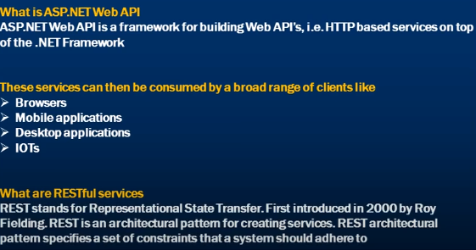

## WCF V/S Web API

* Web API provides supports for convention-based CRUD Actions since it works with HTTP verbs ( GET, PUT, POST, and DELETE)
* It is easy to define, expose, and consume in a REST-ful way.
* ASP.Net Web API allows you to showcase your data and services to various devices.
* Web API is open source, so it is an ideal option for creating RESTful services over the .NET platform.
* Allows you scalable, decoupled development of a Web Service which can be shared and used by other developers to access web services.
* It is also helpful to build simple, non-SOAP-based HTTP Services.
* Supports TDD
* Available from .net framework 4.0
* 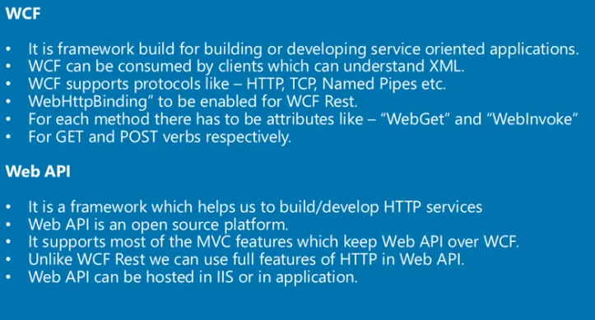

| **Parameter** | **WCF** | **Web API** |
| --- | --- | --- |
| Message Exchange Pattern | Request reply, one-way, or duplex. | By default request-reply only. However, additional message pattern can be supported with web sockets integration. |
| Hosting | IIS hosting, Self-hosting & works activation services. | Self-hosting & IIS hosting. |
| Open Source | It is not open source software. | It is shipped with.Net framework.It is also available as an independent download. |
| Support for MVC features | WCF does not provide any support for MVC features like controllers, routing, filter, auction results, etc. | ASP.NET Web API supports MVC features like routing, controllers, results, filter, action, etc. |
| Encoding support | Text, MTOM, and Binary. | Default support for UTF-8 encoding format. |
| Support for | Support for HTTP, UDP, and custom transport protocol. | Supports only HTTP protocol |
| Use of model | User attributed based programming model. | Maps HTTP verbs to methods |
| Configuration | Uses web.config and attributes to configure a HttpConfiguration class but not on the web.config Service. | Web API can be configured using web.config service. |
| RESTful services | It offers supports for RESTFUL service but with limitations. | Ideal for building RESTFUL services. |

## REST

## 

## Configure Web API/WebApiConfig

1. Web API supports code based configuration. It cannot be configured in web.config file. We can configure Web API to customize the behaviour of Web API hosting *infrastructure and components such as routes, formatters, filters, DependencyResolver, MessageHandlers, ParamterBindingRules, properties, services* etc.

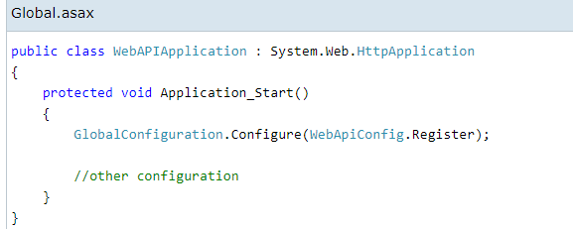

|  |  |
| --- | --- |
|  |  |

## Controller

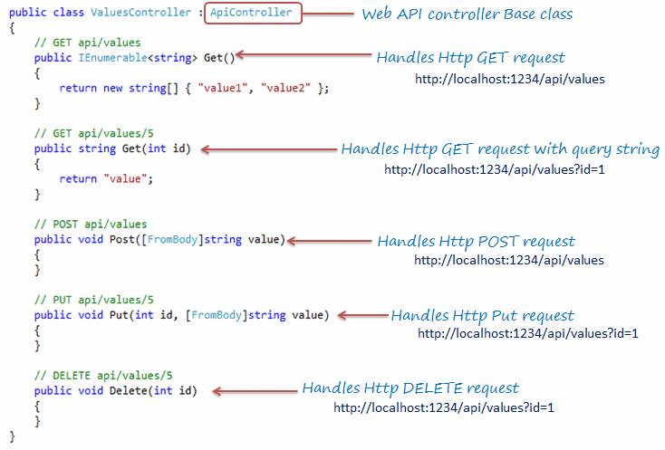

## Web API Routing

The Web API Routing module is responsible for mapping the incoming HTTP requests to a particular controller action method.

We can do routing in three types:

1. Global level
2. Controller level
3. Action level

## Convention-based Routing/Global Level

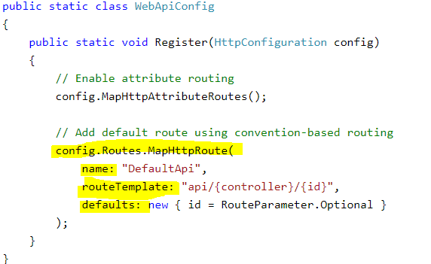

The config.Routes is a route table or route collection of type [HttpRouteCollection](https://msdn.microsoft.com/en-us/library/system.web.http.httproutecollection(v=vs.118).aspx). The "DefaultApi" route is added in the route table using [MapHttpRoute()](https://msdn.microsoft.com/en-us/library/hh835153(v=vs.118).aspx) extension method. The MapHttpRoute() extension method internally creates a new instance of [IHttpRoute](https://msdn.microsoft.com/en-us/library/system.web.http.routing.ihttproute(v=vs.118).aspx) and adds it to an HttpRouteCollection. However, you can create a new route and add it into a collection manually as shown below.

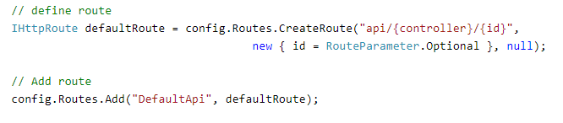

Configure Multiple Routes

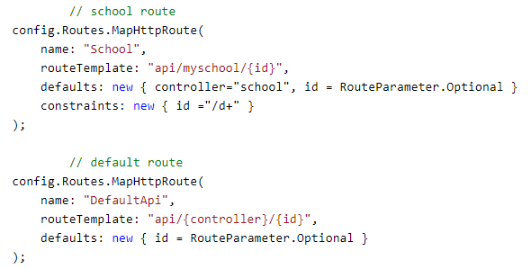

In the above example, School route is configured before DefaultApi route. So any incoming request will be matched with the School route first and if incoming request url does not match with it then only it will be matched with DefaultApi route.

## Attribute (Controll/Method Level) Routing

Attribute routing is supported in Web API 2. As the name implies, attribute routing uses [Route()] attribute to define routes. The Route attribute can be applied on any controller or action method

*In order to use attribute routing with Web API, it must be enabled in WebApiConfig by calling config.MapHttpAttributeRoutes() method*

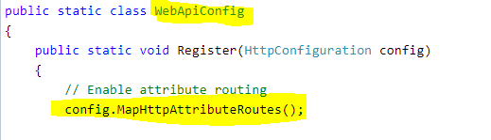

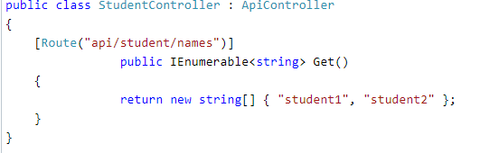

## Why Attribute Routing?

The first release of Web API used convention-based routing. One advantage of convention-based routing is that templates are defined in a single place, and the routing rules are applied consistently across all controllers. Unfortunately, convention-based routing makes it hard to support certain URI patterns that are common in RESTful APIs. Attribute routing can be combined with [convention-based](https://docs.microsoft.com/en-us/aspnet/web-api/overview/web-api-routing-and-actions/routing-in-aspnet-web-api) routing. To define convention-based routes, call the **MapHttpRoute** method

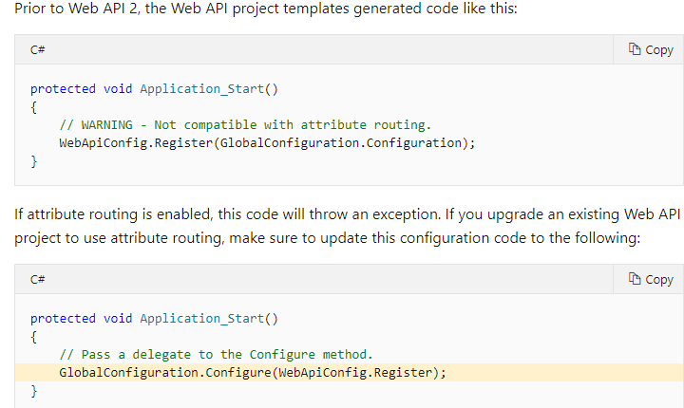

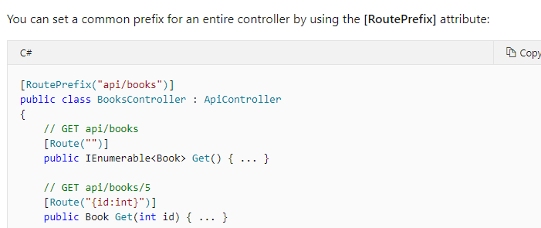

**API versioning**

In this example, "/api/v1/products" would be routed to a different controller than "/api/v2/products".

/api/v1/products /api/v2/products

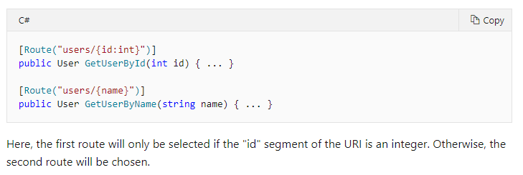

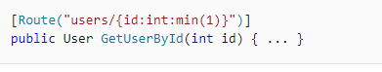

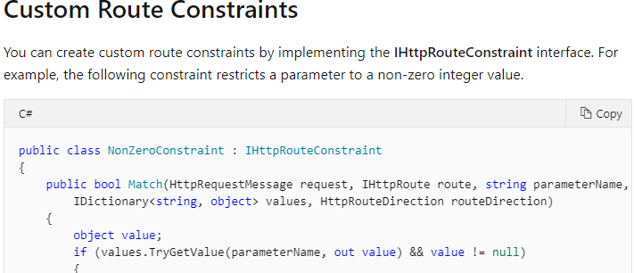

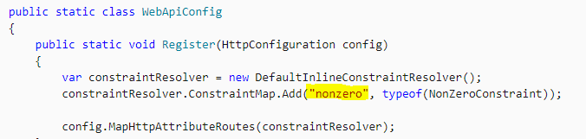

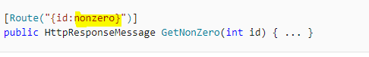

## Optional URI Parameters and Default Values

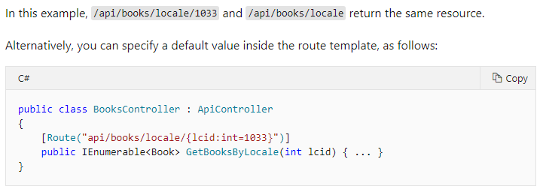

## VERBS

## https://csharpcorner.azureedge.net/article/temp/56102/Images/image001.gif

* [HttpGet]
* [HttpPut]
* [HttpPost]
* [HttpDelete]
* [HttpHead]
* [HttpOptions]
* [HttpPatch]

To allow multiple HTTP verbs for an action, or to allow HTTP verbs other than GET, PUT, POST, DELETE, HEAD, OPTIONS, and PATCH, use the [AcceptVerbs] attribute, which takes a list of HTTP verbs.

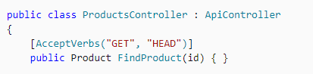

## Parameter Binding

| HTTP Method | Query String | Request Body |
| --- | --- | --- |
| GET | Primitive Type, Complex Type | NA |
| POST | Primitive Type | Complex Type |
| PUT | Primitive Type | Complex Type |
| PATCH | Primitive Type | Complex Type |
| DELETE | Primitive Type, Complex Type | NA |

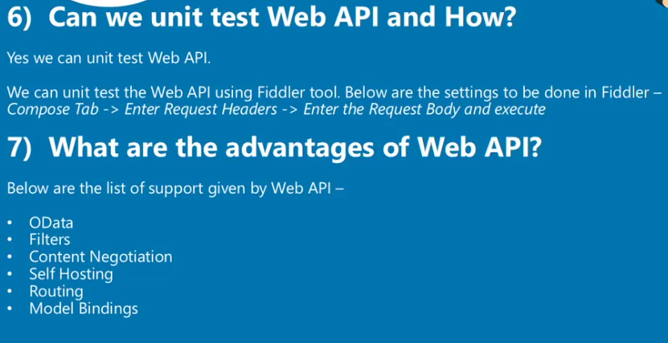

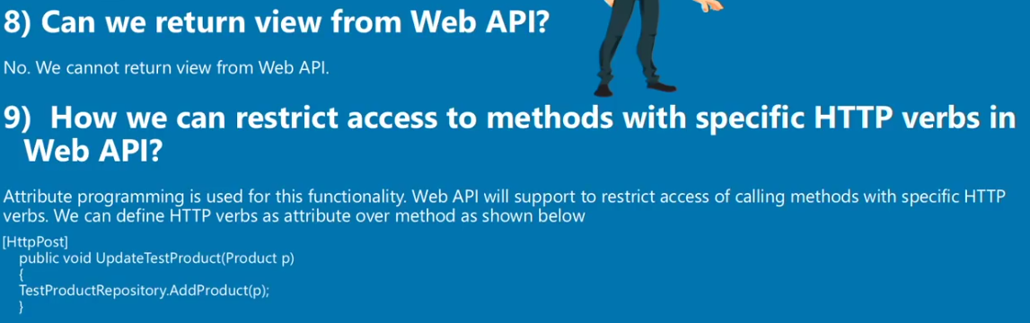

## Method Names



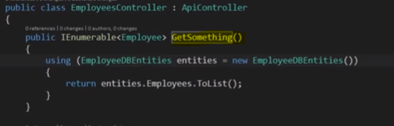

Will work

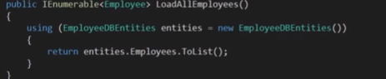

Will not work

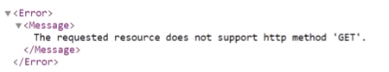

Sol :

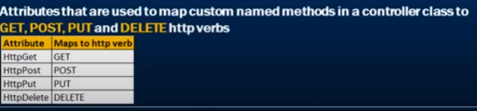

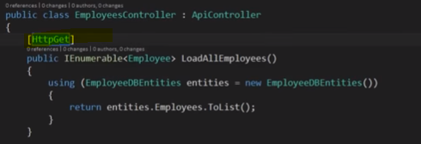

## CUSTOM/ALIAS names



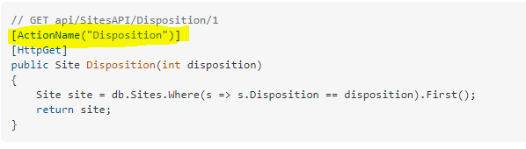

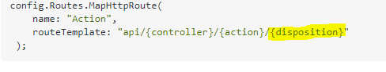

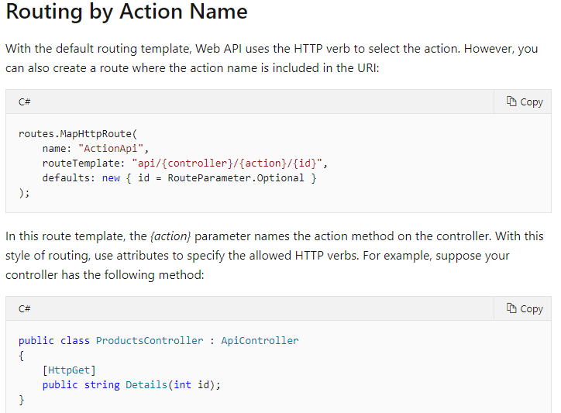

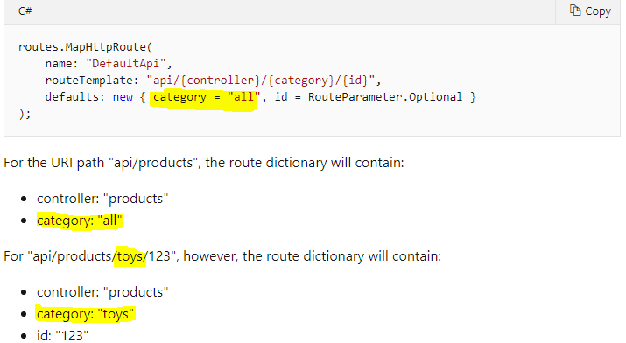

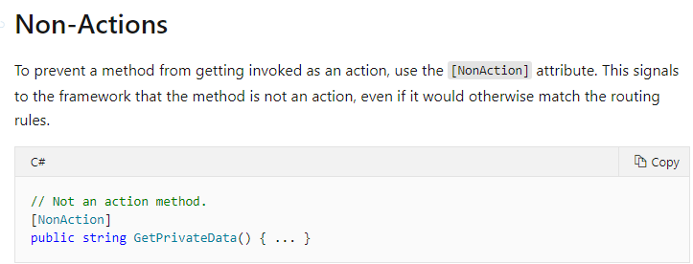

## Web API Filters

Web API includes filters to add extra logic before or after action method executes. Filters can be used to provide cross-cutting features such as logging, exception handling, performance measurement, authentication and authorization.

Filters are actually attributes that can be applied on the Web API controller or one or more action methods. Every filter attribute class must implement IFilter interface included in System.Web.Http.Filters namespace.

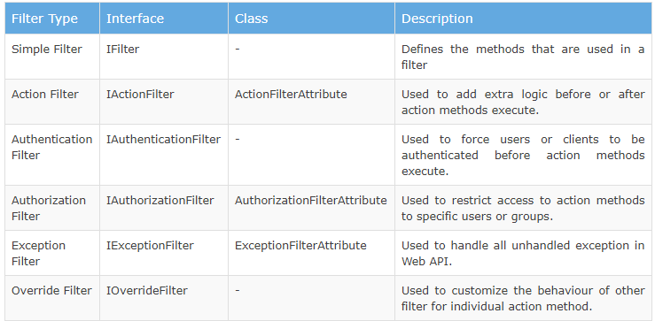

There are [**different filter types**](https://code-maze.com/filters-in-asp-net-core-mvc/):

* **Authorization filters** – They run first to determine whether a user is authorized for the current request
* **Resource filters** – They run right after the authorization filters and are very useful for caching and performance
* **Action filters** – They run right before and after the action method execution
* **Exception filters** – They are used to handle exceptions before the response body is populated
* **Result filters**– They run before and after the execution of the action methods result.

Action Filter Example :

Synch Way

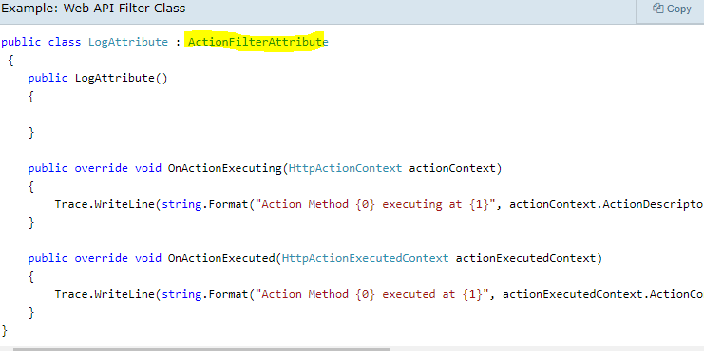

Asynch Way:

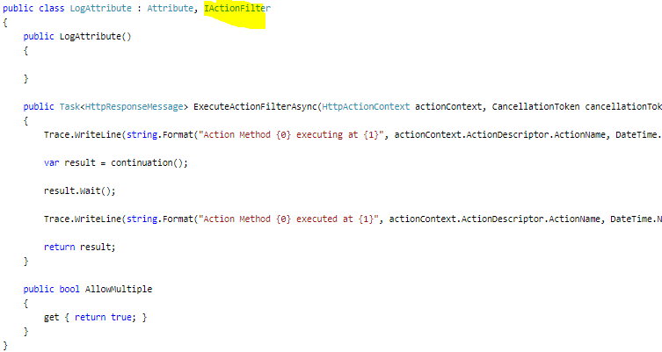

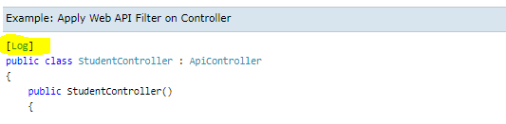

## Versioning in API

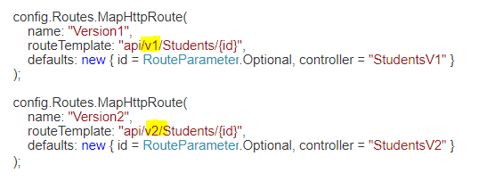

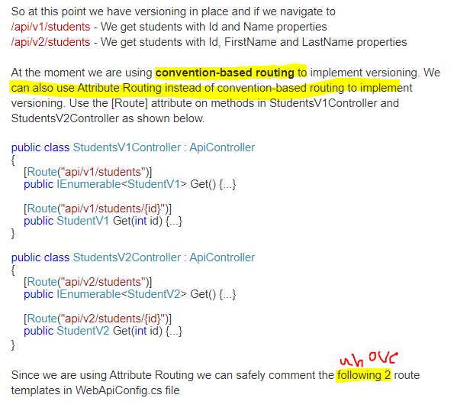

## authentication and authorization in web api

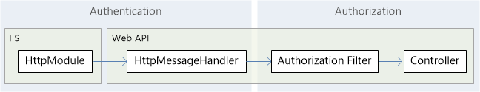

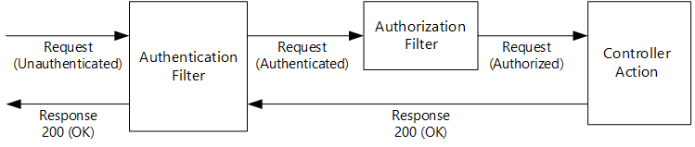

## Authentication

When the host authenticates the user, it creates a principal, which is an [IPrincipal](https://msdn.microsoft.com/library/System.Security.Principal.IPrincipal.aspx) object that represents the security context under which code is running. The host attaches the principal to the current thread by setting **Thread.CurrentPrincipal**. The principal contains an associated **Identity** object that contains information about the user. If the user is authenticated, the **Identity.IsAuthenticated** property returns **true**. For anonymous requests, **IsAuthenticated** returns **false**.

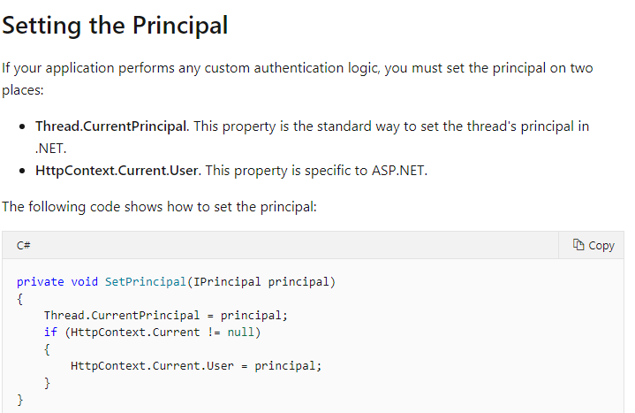

Example :

**Create basic authentication filter**  
1. Add a new class file to **EmployeeService**Web API project. Name it **BasicAuthenticationAttribute.cs**

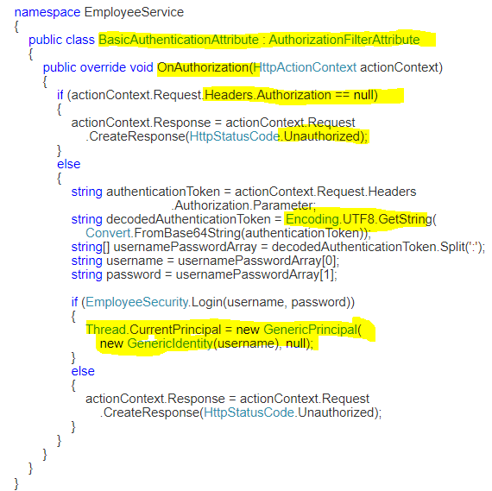

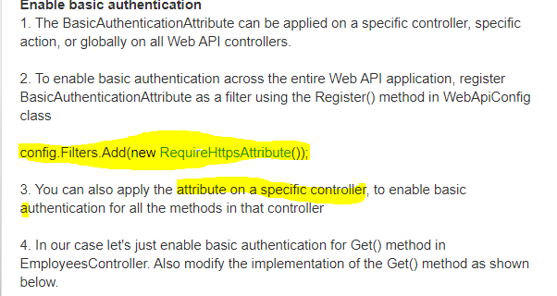

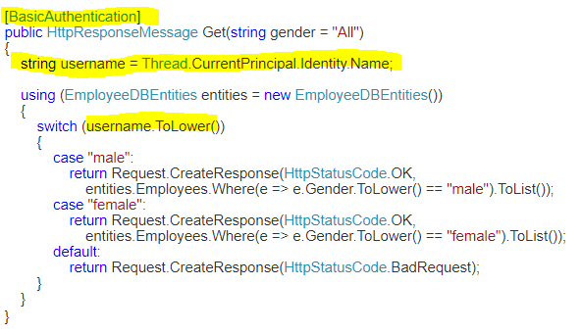

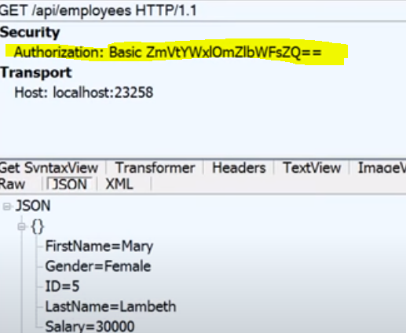

<https://docs.microsoft.com/en-us/aspnet/web-api/overview/security/authentication-filters>

## ASP.NET Web API enable HTTPS

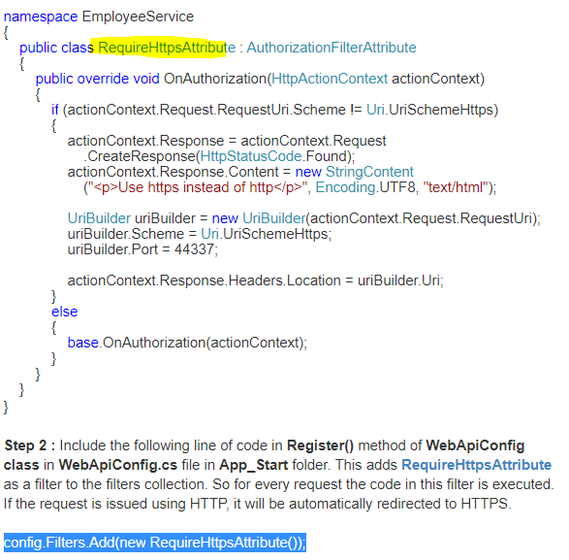

## aspnet-web-api-token-authentication

bearer token authentication with/without swagger web api sample

## Web api bearer token example

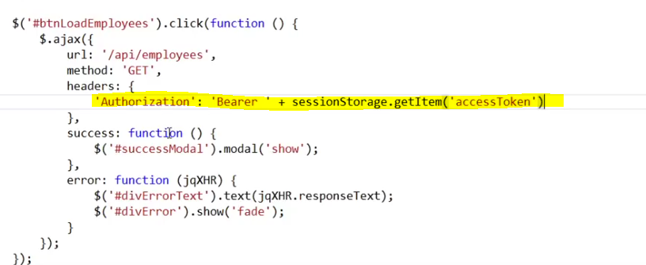

The name “**Bearer authentication**” can be understood as “give access to the **bearer** of this **token**.” The **bearer token** is a cryptic string, usually generated by the server in response to a login request.

<https://www.youtube.com/watch?v=8mHFxrGC88U>

<https://doc.sitecore.com/developers/91/sitecore-experience-manager/en/use-bearer-tokens-in-client-applications.html>

## aspnet-core-3-role-based-authorization-tutorial-with-example-api

## CORS web api-

**Enable CORS** (Cross Origin Resource Sharing)

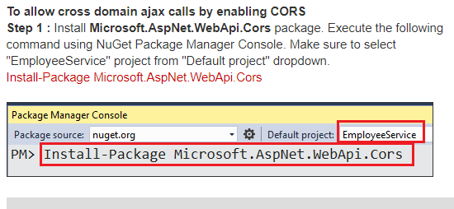

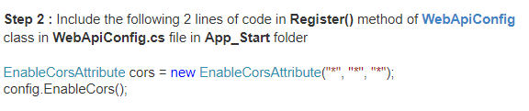

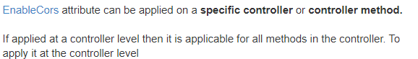

***Cors feature only included in .net 4.5 and web api2***

When CORS is enabled, the browser sets the **origin**header of the request to the domain of the site making the request. The server sets **Access-Control-Allow-Origin** header in the response to either * or the origin that made the request. * indicates any site is allowed to make the request.

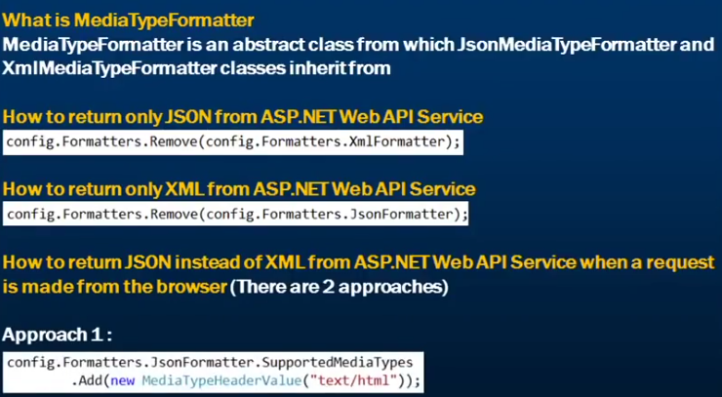

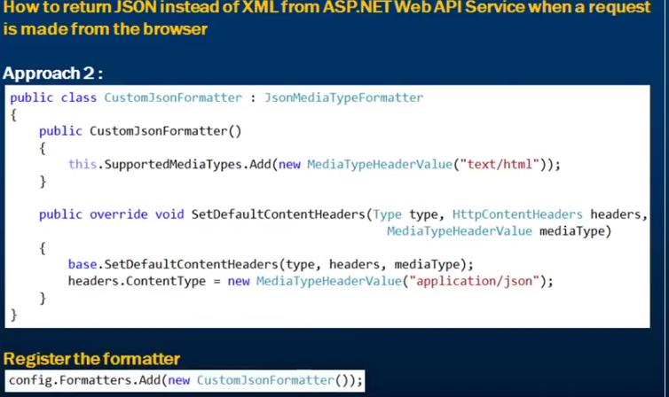

## Action Method Return Type

In the previous section, you learned about parameter binding with Web API action method. Here, you will learn about the return types of action methods which in turn will be embedded in the Web API response sent to the client.

The Web API action method can have following return types.

1. Void
2. Primitive type or Complex type
3. HttpResponseMessage
4. IHttpActionResult

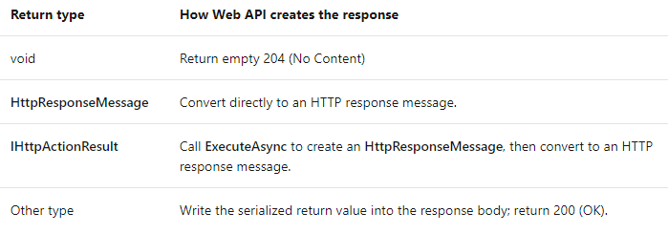

[***https://www.tutorialsteacher.com/webapi/action-method-return-type-in-web-api***](https://www.tutorialsteacher.com/webapi/action-method-return-type-in-web-api)

[***https://docs.microsoft.com/en-us/aspnet/web-api/overview/getting-started-with-aspnet-web-api/action-results***](https://docs.microsoft.com/en-us/aspnet/web-api/overview/getting-started-with-aspnet-web-api/action-results)

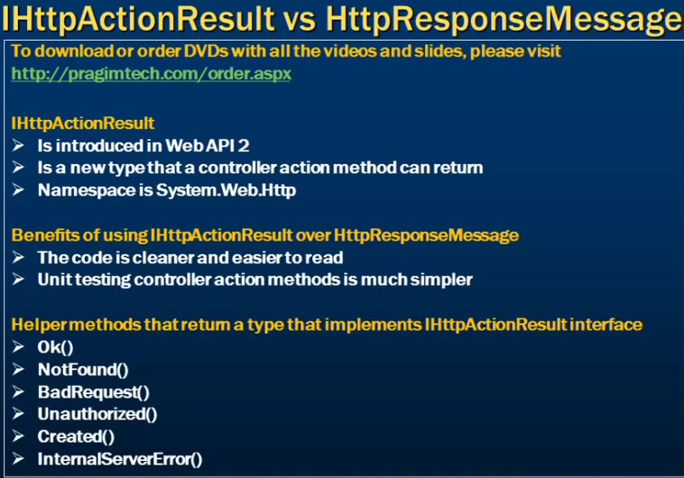

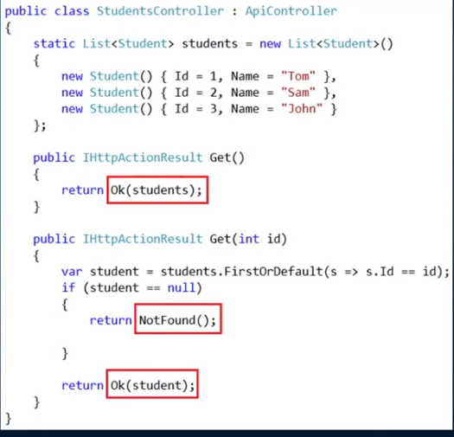

## OWIN/IIS HOSTING

## AZURE HOSTING

## DOCKER HOSTING